Understanding the home workshop: project space, project time, and material interaction.
Dr Andrew Jackson
Canterbury Christ Church University
Email: andrew.jackson@canterbury.ac.uk
Tel: 07725 486962
Dr Andrew Jackson is a senior lecturer at Canterbury Christ Church University, and has a background both as a professional maker, and as a lecturer in design, creativity and strategy. His research interests are centered around cultures of consumption, particularly focusing on understanding vernacular design culture, and the intrinsic motivations associated with amateur design and craft practice.
Abstract
This article is developed from a qualitative study of amateur makers who built and used home workshops as part of their leisure activities. The research aimed to develop an account of the individual’s experience of making, and the ways in which they used accumulations of tools and materials in conjunction with special kinds of spaces in order to make their activities possible. The article argues that not only do amateur makers enter a special kind of ‘project space’ when they go into their workshops, they also portion off a special kind of ‘project time’, a temporal space within which their activities can take place. Turning to ideas about situated cognition, the article argues that these workspaces create external ‘scaffolding’ which is an essential component of the makers’ continuous problem solving process. The article concludes that working in workshops with tools and materials, amateur makers are able to derive aesthetic satisfaction by being intertwined in simultaneous interactions between themselves and their environment.

Keywords: home workshops, material interaction, amateur, making, tools and materials.
Understanding the home workshop: project space, project time, and material interaction.

Introduction
This article is developed from a qualitative study of amateur makers who built and used home workshops as part of a leisure pursuit. These people are amateurs in the sense that their main income comes from some form of paid employment that is separate to their making activity; they are deeply involved in amateur activities that require much time, effort, and skill, yet produce little, or no financial or status compensation. Rather than focusing on an analysis of the results and outcomes of amateur making activities, the research set out to develop an account of the individual’s direct experience of making, asking how we can better understand the motivations of people voluntarily embarking on sustained ‘careers’ as makers outside of, and in addition to, their conventionally paid work.
Whilst the original research considered a number of different aspects of the experience of amateur makers (references omitted for the purposes of blind review), this article focuses on one aspect of their activity, the role of the workspace. The article proposes that making is a practice that depends on a network of physical resources, and embodied interaction with environments and processes. Although the focus of the original research was on amateur practice, the findings are applicable across a range of situations where the interior functions as part of creative making process, both professional and amateur. I define the workshop as special kind of space that extends and enhances the capabilities of the individual, and is constituted by what might be termed ‘distributed competence’ (Shove & Watson, 2008). The research asks: how do makers mobilise the spaces and material resources necessary to carry out their making activities, and what role do these this play in generating a satisfying experience for them? The findings of the research allow us to re-examine the apparently simple phenomenon of the home workshop, and understand the complex ways in which spaces, artefacts and agents interact as part of the creative process.
The research took an interpretive approach based around a series of 14 case studies, plus site visits, interviews, and photography. These were supplemented by study visits to the archive at the Museum of Domestic Design and Architecture at Middlesex University, visits to retailers, events and fairs related to amateur making, and reviews of the theoretical literature associated with the topic area. The primary criteria for sampling were that the participants should be engaged in pursuits that were substantial enough for them to require a dedicated workspace, and to be engaged in the long-term acquisition of a range of special skills and material resources. The people considered in this research made furniture, jewellery, model engineering projects, canoes and cars. They all used a variety of tools, machines and materials in their constructions, carrying out work-like activity as a form of leisure.
The research aims to understand amateur making not purely as the creation of discrete artefacts, but to focus instead on the experience of making, and the material interaction that occurs within particular kinds of specialised interior. A review of published research into do-it-yourself, home crafts, and other amateur making activity, reveals a gap in the way the area has been considered. In their discussion of the incentives for amateur making, existing studies have tended to concentrate on the instrumental benefits offered by the outcomes of the activity. There are discussions of the rational utilitarian and economic benefits associated with do-it-yourself, including the saving of money that would otherwise be spent on hiring trades-people, the opportunity to implement home improvement schemes that would otherwise be out of the economic reach of the householder, and growing the resale value of a house (Atkinson, 2006; Dent, 1997; Edwards, 2006; Goldstein, 1998; Hackney, 2006; Rosenburg, 2011). Other studies focus on the rewarding social qualities of wide ranges of general amateur activity (Leadbeater & Miller, 2004; Stebbins, 1992, 1996, 1997), whilst studies focused more closely on the area of home crafts and do-it-yourself consider the material expression and objectification of cultural identity, gender and class (Beegan & Atkinson, 2008; Buszek, 2011; Gelber, 1997, 1999; Miller, 1990; Moorhouse, 1991; Putnam & Newton, 1990; Triggs, 2006). Finally, a number of studies consider the representational and symbolic qualities of the outcomes of the activity, for example through conspicuous displays of wealth and cultural capital (Attfield, 2000; Clarke, 2001; Featherstone, 1991; Turney, 2004).
The significance of the research discussed in this article is its departure from these precedents, considering instead those practices for which the extrinsic rewards are minimal, and which are therefore largely motivated by rewards that are intrinsic to the activity itself. Although utilizing many of the same aptitudes and material resources that are enabling factors in small-scale home crafts, house maintenance and home improvement, the subjects chosen for this study have deliberately moved on from these activities. They are committed to the making of complex and discrete objects that often have value to only the makers themselves, and that demand high levels of skill and material resources, including the development of specialised spaces within which they can pursue their interests.

Serious making
At a basic, or ‘entry’ level, general purpose tool kits suffice for home crafts and do-it-yourself. At this level the space used for making projects may be multi-purpose, such as the dining room table or the study room, and quickly converted back to normal domestic use at the end of a work session. However, the range of tools and materials required by the makers in this study made it necessary for them to maintain dedicated workspaces. These were often in parts of their homes devoted to their pastime, or in specialised outbuildings, some of which had been built from scratch by the makers themselves. These ranged from simple wooden shed-like structures through to brick-built workshops (see Figures 1 & 2).
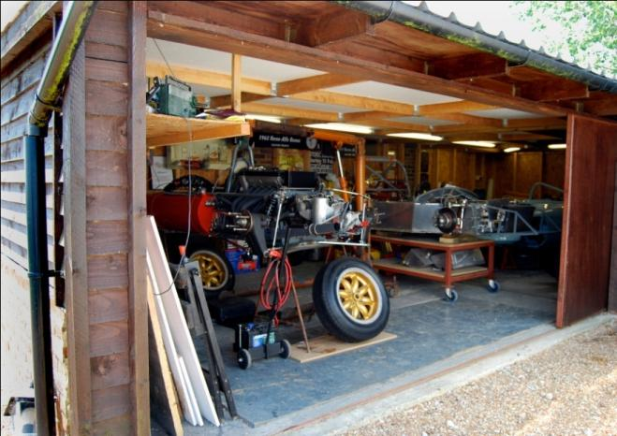
Fig 1: Eric’s self-built timber workshop used for restoring vintage Formula 1 racing cars.
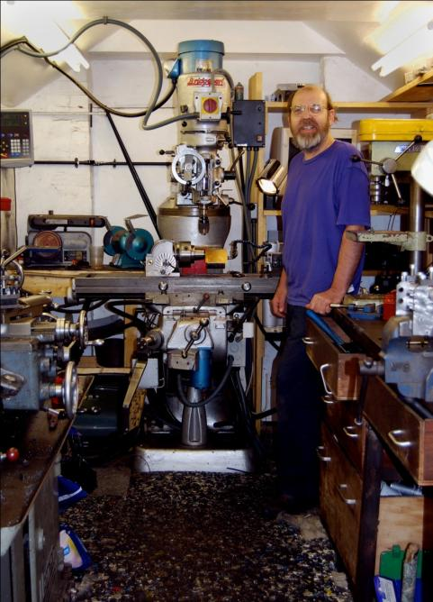
Fig 2: Brian and his reclaimed Bridgeport milling machine installed in his self-built brick out-building designed for use as a model engineering workshop
Tim¹ a furniture maker, told me how he had constructed his workshop during his summer break as an academic at a London University:
... in the summer I put up a big outbuilding. It’s ten feet by twenty feet but, you know, starting with the concrete foundations and building the whole timber structure and whatever and putting in the windows (…) Half of it is a beginner’s workshop, and the other half is a wood store, we have wood burners.
These spaces and sets of tools were often equivalent or better than the equipment used by some professionals working in the same field – in this sense, these makers were a kind of professional/amateur hybrid. The social researchers Leadbeater and Miller have defined these kinds of practitioners as ‘Pro-Ams’. In their report The Pro-Am Revolution (2004), they observed how Pro-Ams in all areas, from sports and music, to astronomy and software programming, are able to achieve results that are often as good as, if not better than those achieved by professionals working in the same area. Many of the Pro-Ams identified in their report sink large amounts of their professional income into their amateur activities. The cost of achieving professional standards, however, is continually falling; affordable amateur equipment is now equal in sophistication to the professional equivalent. The increasing sophistication and availability of power tools, for instance, means that amateur makers now have techniques and processes at their disposal that twenty years ago would only be available to professionals (see figure 3).
Fig 3: Some of Donald’s collection of semi-pro power tools.
Leadbeater and Miller identify the place of Pro-Ams by positioning them on a continuum between professional and amateur:
Pro-Ams
Devotees, fans, dabblers and spectators | Skilled amateurs | Serious and committed amateurs | Quasi-professionals | Fully-fledged professionals

(Adapted from Leadbeater & Miller, 2004: 20)
According to Leadbeater and Miller, the Pro-Am pursues an activity as an amateur, mainly for the love of it, but aims to set a professional standard. Pro-Ams work at their leisure, but they force us to distinguish between “serious leisure” and “casual leisure,” between “active leisure” and “passive leisure.” Above all Pro-Ams report being absorbed in their activities, which yield intense experiences of creativity and self-expression. I will return to these distinctions later in the article, when I will argue that Pro-Am makers are involved in special kind of ‘serious leisure’ with its own characteristics and constraints – a phenomenon first explored in its widest sense by the Canadian sociologist Robert Stebbins (1992, 1997). Firstly, I want to explore in more detail the kinds of spaces created by these makers.

The material capital of the workshop
In this section I explore the ways in which the makers used accumulations of tools and materials in conjunction with special kinds of spaces in order to make their activities possible. The tools and machinery, the stocks of materials and components, and the workshops that were necessary for the makers to sustain their pursuit can be termed material capital².The material capital associated with amateur making is made up of the physical elements of the environment that enable the makers to engage with their activity, and to sustain the activity in the future.
Although the cases varied in detail, certain elements were common across the study. The tools and equipment tended to be tailored towards the materials being worked, the processes used in the area of making being tackled, and the scale of the projects. Cherry, a jewellery maker interviewed as part of the study, had a tool kit that could fit into a few portable boxes (though her bench was a more substantial permanent fixture). Jenny, a furniture maker, was fortunate enough to have an existing outbuilding at her farmhouse that she had converted into a furniture workshop, complete with dust extraction systems, and an elaborate arrangement of tool and materials storage (see figure 4).
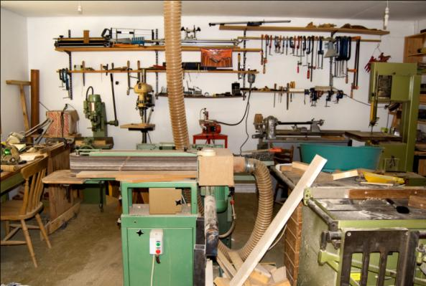
Fig 4: Jenny’s wood workshop complete with dust extraction system.
The acquisition and maintenance of a workspace had become an important part of how all the makers planned their lives. Peter, a woodworker, used to have a separate outbuilding. However, he had recently moved home and lost the use of this space. In his subsequent hunt for a new place to live, he had specifically sought rented accommodation that included a basement suitable for use as a workshop, and that was sound proof so that his activities did not disturb his neighbours. This had significantly reduced the range of rented accommodation available to him, and he recognized that this was an indication of the importance of his making activities to his life outside his work as a mental health nurse:
… when I was thinking about looking for flats, I sort of wondered am I overemphasizing something, because I was looking at things for the criteria of where is there going to be a workspace, or how am I going to do this, is there somewhere I can plug in the power, you know. And then every so often I have to think am I over-valuing, because maybe I could actually get a nicer flat in a nicer area if I didn’t have this criteria, but it feels like a really nice feeling if you can have a work space …
Greg, a kayak builder, also felt that the workshop was essential to his lifestyle, describing his workshop as: ‘…vital, I couldn’t do what I wanted to do without it. A workshop, it’s like perhaps a shed, sort of thing isn’t it? You’ve got somewhere to go, you’ve got tools, and you can make things…’
All of the makers paid a great deal of attention to the ordering and storing of the components of their making activities, and often as much care and ingenuity was lavished upon these aspects of the workshop organization as on the artefacts under construction. Furnishings and fitments in the workshops ranged from reused and adapted domestic and office furniture, through to purpose designed and built units and the use of trade storage systems (see figures 5 and 6).
Fig 5: Jenny’s reclaimed office filing system used as storage for furniture fittings.
Fig 6: Brian’s custom built tool storage system with his refurbished lathe.
As well as being stored in chests and boxes, tools were frequently displayed on toolboards, with each tool hung on pegs attached to a vertical surface attached to a wall, often behind a work bench or associated piece of machinery (see figure 7). This had the practical advantage of storing them in a way that allowed them to be easily found, but also allowed the makers to display their tools, often in sets of diminishing size, or common function. As Greg recognized, in addition to creating workshops, for many participants the opportunity to acquire and maintain a range of specialized tools was one of the continuing motivations for taking part in the pursuit. He told me ‘… I’m a tool freak, I must admit, and any tool that will make my life easier, I just love the whole idea of using them.’ The makers accumulated these sets of tools sometimes over a lifetime, with some being inherited or acquired as gifts, and some purchased as an individual project demanded.
Fig 7: Greg’s specialised tool collection including his Japanese saws.
Greg was particularly proud of his Japanese saw collection, telling me:
I do like high quality stuff, you can’t beat those Japanese saws. They are actually called Japanese razor saws, and when you change the blade and have a brand new one, especially in that one, the one with the back on it – if you have a look at the blade it is very, very fine. (...) They are [available] online but they have a shop in Sittingbourne, which is like a warehouse full of gorgeous tools and stuff.
Simon, a wood turner, not only mounted his wood turning tools on the wall, but also displayed various forms of memorabilia, including a half-completed electric guitar, and a painting by his grandfather, from whom he thought he had inherited his talent for making (see figure 8). Eric, who restored Formula One racing cars, displayed classic car racing memorabilia and posters amongst his tools and equipment.
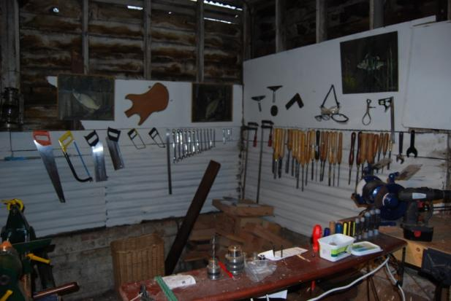
Fig 8: Simon’s tool boards and making memorabilia.
These interiors become special kinds of ‘project spaces’ and, as Tim noted, the advantages of these kinds of spaces are that not only do they allow the work in progress and accompanying tools to be left out in between project sessions, they also offer a sense of order in a controlled private world:
Well I suppose there’s a certain order to things, your tools are there, they’re ready to hand ... a dedicated workshop, the appeal of it is, I guess, you know where your tools are, nothing else is going on in there, you don’t have to move things as you’re working on a project, you don’t have to pack up and clean up at the end of the day; you can simply continue… I suppose as well even in the imagination, even if you’re not using it for a while, you know, if you’re too busy with other things, I would think of it as um, it’s psychologically pleasing to think that the refuge is there. You know, and that if you really need to escape you can go there, there’s a physical space to go to like where you can do something else.
Tim calls to mind Heidegger’s phrase of ‘readiness-to-hand’ (Heidegger, 1962 [1927]: 188-190 cited in Wrathall, 2006 : 38-39). For Heidegger readiness-to-hand is more than just an object or tool being available for our use, it is an understanding of the full potential of the tool’s use in the context within which the maker interacts with their environment and equipment – or, to use Heideggerian terminology, Zeug, which is loosely interpreted as ‘stuff ‘or ‘gear’ (Dant, 2005: 87). Like the word equipment, Zeug can be thought of as a collective noun – equipment in this collective sense always exists in a network of other tools and organisations; e.g. the plane is on the bench in the space that I use as a workshop. Ready-to-hand is available thorough physical proximity to the human body (hanging on the tool board, or sitting on the bench from the last time the maker was in the workshop) but also understood as usable for action, and part of a range of other resources that are recognised as being available to the maker (see figure 9).
Fig 9: Donald’s plane and bench are ready-to-hand.
So, workshops exist as an accumulation of material capital that has to work as an integrated and cohesive whole in order to allow making processes to take place; an arrangement of available devices and ready to hand resources. To function effectively the elements of the workshop also depend on their positioning in a defined space, and in the relation between each of them. But this arrangement is always contingent. It will be constantly modified by the users of the workshop, who will add tools to the mix and take them away again according to circumstance. Greg described how he alters the layout of his workshop according to the size of kayak he is making and Eric’s semi-completed cars dominate his space, being relocated to various positions as they near completion. The workshop is a fluctuating and morphing entity, which nevertheless, possesses a great deal of power, enabling practices that would otherwise be impossible. The space becomes 'competent' in a direct relationship to the skills, knowledge and experience of the maker – progressively matching the competence of the individual as it grows, each element enhancing and extending their capacity to act on the world.
To use Gibson’s term, the workshop offers ‘affordance’ (Gibson, 1977); this is the possibility for use, intervention and interaction offered by a local environment to an embodied agent (Fisher, 2004, 2005). The ways in which it is organised, the tools and materials it contains, and the actions it makes possible, gives the workshop and its equipment a form of agency, and offers affordance to the maker. Different actors will perceive the affordances offered by a single object in different ways depending on their circumstance and outlook – an adult will recognise the table as a platform for eating from, or a social centre, whilst a small child might perceive a dining table quite differently, perhaps seeing it as an imaginary house or shelter (Csikszentmihalyi, 2009 [1991]). In a wood working shop the bench is not just a table, but a tool that depends on its mass and stability to support the work piece, offering inertia against hammering and cutting actions, and providing gripping with vices and cramps. I return to the ways in which the physical resources of the work shop support and extend the capabilities of the individual later in the article. Firstly I want to consider how the workspace can understood in terms of time, and its place in the everyday life of the maker. I explore the ways in which the makers’ activity and use of space is temporally located, considering two moments: the moment that is part of a specific category of everyday life, and the moment that is a component of the making process, and the relation of this moment to the materiality of the space.

The space as a moment in everyday life
If amateur makers enter a special kind of space when they go into their workshop to make things, in order to proceed they are also required to portion off a special kind of time, a temporal space within which their activities can take place. This time, whether easily accessible or taken with difficulty against of other time commitments, tends to be separated from the cycles of everyday life, and is what we might call ‘project time’. For Cherry, her work space and her time were intimately connected; the workshop was physically and mentally separated from her everyday obligations, and a place of uninterrupted concentration where she could get ‘in the zone’:
… when I am working in the house I would just think: right, I’ll just put the washing on, and then I would come back, and say, right, I’m going to put the washing out, blah, blah, blah, so I am constantly, I am not in the zone. I am not there at the work, I am constantly distracted, and think oh I’ll go and put the kettle on, oh I’ll go and have some lunch in the kitchen, and you know, somebody knocks at the door, or anything like that. I would much rather go somewhere where it’s just me, my work, and just make. I couldn’t do that in the house.
We can see that making as a leisure activity is dependent on the availability and allocation of free time, and that workspaces act as means to bracket and apportion this time. Leisure time is frequently seen by theorists as a form of time ‘left-over’ after other obligations have been fulfilled (Haworth, 1997). The simplest definitions draw a straightforward opposition between work and leisure – in this model work tends to be defined as structured, repetitive and extrinsically rewarded, whilst leisure is defined as being controlled and regulated by the individual themselves, and is seen as containing intrinsic rewards. This understanding, however, presumes a clear-cut distinction, between both work time and leisure time, and between extrinsic and intrinsic rewards, and fails to acknowledge the complexity of the relationships between these factors.
More finely grained models such as that proposed by Parker (cited in Stebbins 1992: 4-5) describe a series of categories that move from work time towards ‘pure’ leisure time, in a series of five stages. Working time or sold time; work related time and work obligations; existence time, and the meeting of physiological needs; non-work obligations; and finally, discretionary, or choosing time – the time that conventionally creates the space for non-instrumental hobbies and pastimes. This final category of time has the character of being available for use at our own discretion, and involves an element of choice and lack of obligation. It is this choosing time that most is most often utilised for making projects, bracketed off by makers as their project time.
Project time passes in a physical space that is quite different both from the space of paid work, and from the space of domestic life. The historian Stephen Gelber, who has carried out extensive research into the hobbies and pastimes of twentieth century America, calls the activities that take place in this time ‘productive leisure’ and notes the difficulties in defining this special kind of time that occupies place between work and free time (Gelber, 1999: 2), whilst Stebbins, who has carried out extensive research in this area, categorise these kinds of activities as ‘serious leisure’ (Stebbins, 1992).
For the ‘serious’ amateur maker their leisure time becomes a hybrid of non-work obligation and choosing time. It is voluntary, but also typically contains a series of obligations to processes and procedures that require optimum periods of time to complete, or resources that have to be acquired, combined with sacrifices that have to be made by them, and their families, when their pursuit takes them away from other aspects of their social lives. Amateur making also exists in a temporal space which is left over after other obligations have either been fulfilled or consciously deferred. It is markedly different to the repetitions of everyday routine, cutting across the cycles of day-to-day living. Whilst these ebb and flow in predictable daily, weekly and seasonal patterns, project time has an indeterminate span that is bounded by beginnings and endings that are quite distinct from the cyclical reverberations of everyday life. For the makers these projects became a form of parallel existence to their normal lives – they constituted worlds that the participants could enter or leave at will, providing a unique space where they were able behave according to different sets of aspirations and obligations. Like the workspace itself, these worlds remain available, even if the makers take a break from their activities for weeks, or even months – for there is always an element of the project that can be resumed when resources allow. As Watson and Shove have pointed out ‘projects constitute ‘orchestrating’ forces, condensing diverse resources and energies around specific goals’ (2008: 81).

Space as part of the moment of making
As well as helping to demarcate particular kinds of time and separate them from everyday life, the workspace also envelopes the maker in an immersive environment. To return to a theme introduced earlier in this article, the work space not only modifies expectations and experience, but also functions as an extension of the maker’s body and capabilities.
Tools and devices literally expand the maker’s body, making arms longer, offering leverage and momentum, increasing gripping and holding power, and offering a datum for accurate shaping and cutting. Working in workshops with tools and materials, amateur makers are intertwined in simultaneous interactions between themselves and their environment (Dant, 2005). As well as extending the body, workshops also act as an extension of the mind, with the individual able to use the immediate physical environment as an empirical aid to theoretical mental problem solving – from simple pen and paper to complex jigs (see figure 10), moulds and plans, whole environments can serve memory and calculation by externalising problems, breaking them into manageable chunks and materialising otherwise abstract systems.
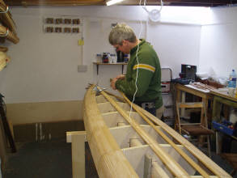
Fig 10: Greg developing a system for fitting the strips of timber that form the hulls of his wood kayaks.
In this sense, the material world of the workshop and the associated tools and machinery are not simply a crutch to help the brain do its work, but actually constitutes part of the mental processes required in order to carry out multifarious tasks. Designers of artificial intelligence systems have recognised this way of working for some time, and realised that attempts to build a whole world model that can be carried around in the ‘brain’ of a robot creates an impossible objective. Instead, they have begun to design systems that have a form of ‘distributed intelligence’ – in other words the knowledge that is required to negotiate tasks in the world remains in the world, and is only accessed by the machine on an as needed basis. For the maker, each encounter in their workshop environment allowed them to access data, information and processes as required, without having to internalise and the whole making process. This merges the processes of reasoning and action in unexpected ways, cutting back and forth across the traditional boundaries of mind, body and environment. In place of the intellectual engine cogitating in a realm of detailed inner models, we confront the embodied, embedded agent acting as an equal partner in adaptive responses which draw on the resources of mind, body and world. The cognitive scientist Andy Clark, describes this as an action loop, where ‘pure thought’ leads to external practical actions, which in turn help to simplify the problems confronting ‘pure thought’ (Clark, 1997: 36). In other words, makers use operations on the world as an intrinsic part of a problem solving process – not just as a material expression of a solution but as part of sequence of operations that lead to the solution. As Tim, the furniture maker observed, the problems encountered in making are not solved before action takes place, but are solved through action and interaction with materials, artefacts and environment: ‘...there are certain stages where you have to be fully focussed on what it is that you're doing. That is your problem, you are solving it as you're doing it’.
This understanding challenges the notion that the individual is able to operate autonomously within the environment, artificially separated from the external framework of information that is necessary to tackle tasks and create new artefacts. Rejecting the Cartesian duality that insists on separating mind and body, this view takes the human as intimately connected to its surroundings and making sense of existence through action and embodied interaction with the material world. The abilities and attributes necessary for a skilled maker to engage with their material environment are acquired, often over a long period of time, and become habitually available as tacit knowledge (see figure 11).
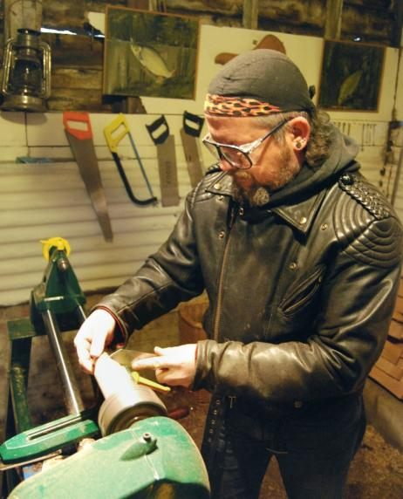
Fig 11: Simon using a parting chisel to separate a newly turned piece from the lathe.
It is the unconscious ease with which a practiced participant engages in a task, the ease of unattended bodily coordination which is embodiment:
... we know that incorporated material culture reaches deep into the psyche of the subject because it reaches it not through abstract knowledge, but through sensori-motor experience’ (Warnier, 2001: 10).
For the maker, this inherence in the material environment, this acting on the world and simultaneous acting of the world on us, becomes not just a means of life, but a source of satisfaction and enjoyment, which transcends the instrumental outcomes of our actions. The study found that part of the motivation for makers is aesthetic, the sensory experience of material interaction and problem solving. The term aesthetic is used here in the original scientific sense to refer to ‘that which appeals to the senses’, with its antonym being anaesthetic, or a general loss of sensual feeling. The appeal of making in a workshop partly arises from the physical sensation of material interactions with tools, materials and process (Dant, 2008; Fisher, 2004). These interactions offer individuals powerful and motivating feelings of competence autonomy and control, both over their environment, and over the materials being worked, encouraging them to continue with pursuits that few monetary, functional or instrumental rewards.

Conclusion
The research found that the material capital of the home workshop was a necessary precedent to the projects undertaken by these makers, remaining ready to hand after individual projects had been completed, and offering a continuing potential for future action. As they developed their skills, the sophistication of the work spaces progressively matched the capabilities of the maker, extending their capabilities and allowing them to achieve their goals by matching the challenge of their projects with the competence of their project space.
I have argued, however, that working in workshops is also strongly bound by notions of time, with strong distinctions emerging between the cyclical time of everyday life, and the ‘project time’ of making, with projects having an indeterminate span that is bounded by a beginning and an ending, and that overlays the repetition of normal routine. I have argued that this is a special kind of temporal measure that provides a unique time and space where amateur makers are able behave according to different sets of aspirations and obligations. I have also argued that these pursuits are a practice that depends on a network of physical resources, and embodied interaction with special kinds of environments and processes. If amateur makers enter project time when they are making things, to go into the workshop is to enter the ‘project space’. Turning to ideas about situated cognition, I argued that this relationship with the physical world extended the mind of the makers, allowing their calculations to be carried out in the external world, freeing them from overwhelming abstract calculations, and allowing their empirical speculation to take place separately from the internal world of abstract thought – creating external ‘scaffolding’ which aided their continuous problem solving, and the iterative physical interaction with the world. Working in workshops with tools and materials, amateur makers derive aesthetic satisfaction by being intertwined in simultaneous interactions between themselves and their environment, by the sensory experience of material interaction and problem solving. The practice of amateur making is thus reproduced and recognised by an embodied engagement which unfolds across time, but is also depends on a spatially and temporally dispersed network of material resources which cannot be reduced to any single element. This inherence in the material world, this acting on the world and simultaneous acting of the world on them, becomes not just a means of life, but a source of satisfaction and enjoyment, which transcends the instrumental outcomes of their actions. This human/object interaction is a form of ‘work’, but it is also a form of productive pleasure seeking.

Notes
The makers interviewed as part of the study have all given permission for their words, and images of their workshops to be published, though their names have been changed to protect their anonymity. All images are by the author unless otherwise specified.
2 The term ‘material capital’ is borrowed from Dant and Wheaton (2007) who use it to refer to the physical kit associated with windsurfing (boards, rigs, wetsuits, harnesses, etc.) and the spaces where windsurfers sail (areas of sea and lakes). Drawing on the work of Bourdieu (1978), they distinguish between the material capital of the kit and embodied capital of the sailor’s embodied skill set.

References:

Atkinson, P. (2006). Do It Yourself: Democracy and Design. Journal of Design History, 19(1), 1-10.

Attfield, J. (2000). Wild Things: The Material Culture of Everyday Life. Oxford and New York: Berg.

Beegan, G., & Atkinson, P. (2008). Professionalism, Amateurism and the Boundaries of Design. Journal of Design History, 21(4), 305-313.

Bourdieu, P. (1978). Sport and Social Class. Social Science and Information, 17(9), 819-840.

Buszek, M. E. (Ed.). (2011). Extra/Ordinary; Craft and Contemporary Art. Durham: Duke University Press.

Clark, A. (1997). Being There: Putting Brain, Body and World Together Again. Cambridge Mass: MIT Press.

Clarke, A. J. (2001). The Aesthetics of Social Aspiration. In D. Miller (Ed.), Home Possessions: Material Culture Behind Closed Doors (pp. 23-45). Oxford: Berg.

Csikszentmihalyi, M. (2009 [1991]). Design and Order in Everyday Life. In B. Highmore (Ed.), The Design Culture Reader (pp. 157-164). London: Routledge.

Dant, T. (2005). Materiality and Society. Maidenhead: Open University Press.

Dant, T. (2008). The 'Pragmatics' of Material Interaction. Journal of Consumer Culture, 8(1), 11-33.

Dant, T., & Wheaton, B. (2007). Windsurfing: An Extreme Form of Material and Embodied Interaction. Anthropology today, 23(6), 8-12.

Dent, J. (Writer) (1997). The DIY Pioneers [Television Broadcast], All Mod Cons. UK: Wall to Wall Television Ltd.

Edwards, C. (2006). Home is Where the Art is: Women Handicrafts and Home Improvements 1750-1900. Journal of Design History, 19(1), 11-21.

Featherstone, M. (1991). Consumer Culture and Postmodernism. London: Sage Publications.

Fisher, T. (2004). What We Touch, Touches Us: Materials, Affects, and Affordances. Design Issues, 20(4), 20-31.

Fisher, T. (2005). Material Interactions - Embodied Exploration of Affordances. Paper presented at the Conference Name|. Retrieved Access Date|. from URL|.

Gelber, S. (1997). Do-It-Yourself: Constructing, Repairing and Maintaining Domestic Masculinity. American Quarterly, 49(1), 66-112.

Gelber, S. (1999). Hobbies: Leisure and the Culture of Work in America. New York: Columbia University Press.

Gibson, J. J. (1977). The Theory of Affordances. In R. Shaw & J.Bransford (Eds.), Perceiving, Acting and Knowing. Hillsdale, NJ: Erlbaum.

Goldstein, C. M. (1998). Do It Yourself: Home Improvement in 20th Century America. New York: Princeton Architectural Press.

Hackney, F. (2006). Use Your Hands for Happiness: Home Craft and Make-do-and-Mend in British Women's Magazines in the 1920s and 1930s. Journal of Design History, 19(1), 23-38.

Haworth, J. (Ed.). (1997). Work, Leisure and Well-being. London: Routledge.

Heidegger, M. (1962 [1927] ). Being and Time (J. Macquarrie & E. Robinson, Trans.). San Francisco: HarperSanFrancisco.

Leadbeater, C., & Miller, P. (2004). The Pro-Am Revolution: How Enthusiasts are Changing our Society and Economy. London: Demos.

Miller, D. (1990). Appropriating the State on the Council Estate. In T. Putnam & C. Newton (Eds.), Household Choices (pp. 43-55). London: Futures Publications.

Moorhouse, H. F. (1991). Driving Ambitions: An Analysis of the American Hot Rod Enthusiasm. Manchester: Manchester University Press.

Putnam, T., & Newton, C. (Eds.). (1990). Household Choices. London: Futures Publications.

Rosenburg, B. C. (2011). Home Improvement: Domestic Taste, DIY, and the Property Market. Home Cultures, 8(1), 5-24.

Shove, E., & Watson, M. (2008). Product, Competence, Project and Practice. Journal of Consumer Culture, 8(1), 69-89.

Stebbins, R. A. (1992). Amateurs Professionals and Serious Leisure. Montreal: McGill-Queens University Press.

Stebbins, R. A. (1996). The Barbershop Singer: Inside the Social World of a Musical Hobby. Toronto: University of Toronto Press.

Stebbins, R. A. (1997). Serious Leisure and Well-Being. In J. T. Haworth (Ed.), Work, Leisure and Well-Being (pp. 117-130). London: Routledge.

Triggs, T. (2006). Scissors and Glue: Punk Fanzines and the Creation of a DIY Aesthetic. Journal of Design History, 19(1), 69-83.

Turney, J. (2004). Here's One I Made Earlier: Making and Living with Home Craft in Contemporary Britain. Journal of Design History, 17(3), 267-281.

Warnier, J.-P. (2001). A Praxeological Approach to Subjectivation in a Material World. Journal of Material Culture, 6(1), 5-24.

Wrathall, M. (2006). How to Read Heidegger. New York: W. W. Norton and Company.

