Tim Long Output 4

Family Tree and Matter & Memory
To be Cross-Referred to Sub-Panel 34: Art & Design – History, Practice & Theory

Research Narrative:
Field of research
Family Tree and Matter and Memory are companion pieces to On reflection (Output 2). All these works engage my ‘playful optics’ that seek to interrogate objective and subjective realities through physical art objects. These experiemnts also continue my research into the paradoxical combination proposed by Antonin Artaud’s subjectile.
Context
Family Tree consists of a white box the same scale as the human head. Set on a low plinth, the viewer is required to bend down to look through an eye-shaped aperture cut through the front of the box. ‘Family Tree’ is lined internally, bottom and sides, with mirrors, and the top is lined with translucent glass to let in light. The mirror is cut away on the inside front to allow the viewer to see into the box. The rear mirror is titled at 5 degrees. Viewers can see their own eye captured and reflected hundreds of times in the multiplying perspectives facilitated by the eccentric properties of the mirror’s reflections. The subject’s eyesight and perceptions are disturbed by the apparently impossible scale of the box’s interior.
Matter and Memory consists of a surgical endoscope (an instrument that can be introduced into the body to give a view of its internal parts) penetrating through an inverted tree trunk stained red and suspended by four rods above a tripod stool. Viewers can look through the tree using the endoscope, to view the other side through a glass orb that refracts and inverts the scene around the object. The work engages the relationships between objective presentation, representation (memory) and material, and plays with the idea of the internal operation of the mechanism of sight. The title of the work is taken from Henri Bergson’s book Matter and Memory (French: Matière et mémoire) of 1896.
Innovation
A Tardis-like disjuncture of interior/exterior spacial proportions is perceived by the viewer. The intention is to present a peculiar and distorted reality symbolising an unsettling relationship to perception and the reality presented through the senses. This is experienced privately since only one person can view the box’s interior at one time, yet it is immediately shared through discussion and mutual curiosity. The work examines how an object can be presented simultaneously as a simulation and a physical thing. (Word Count: 469)

Indicators of Quality: The two art works were selected for the Royal Academy 2010 Summer Exhibition in London, June-August 2010. Work subject to a highly selective peer-review process by the Royal Academy. More than 150,000 people visited the exhibition.
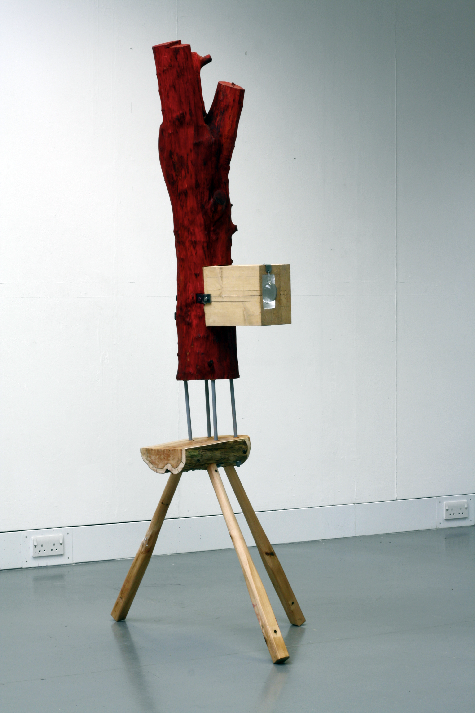
Figure 1 Matter and Memory
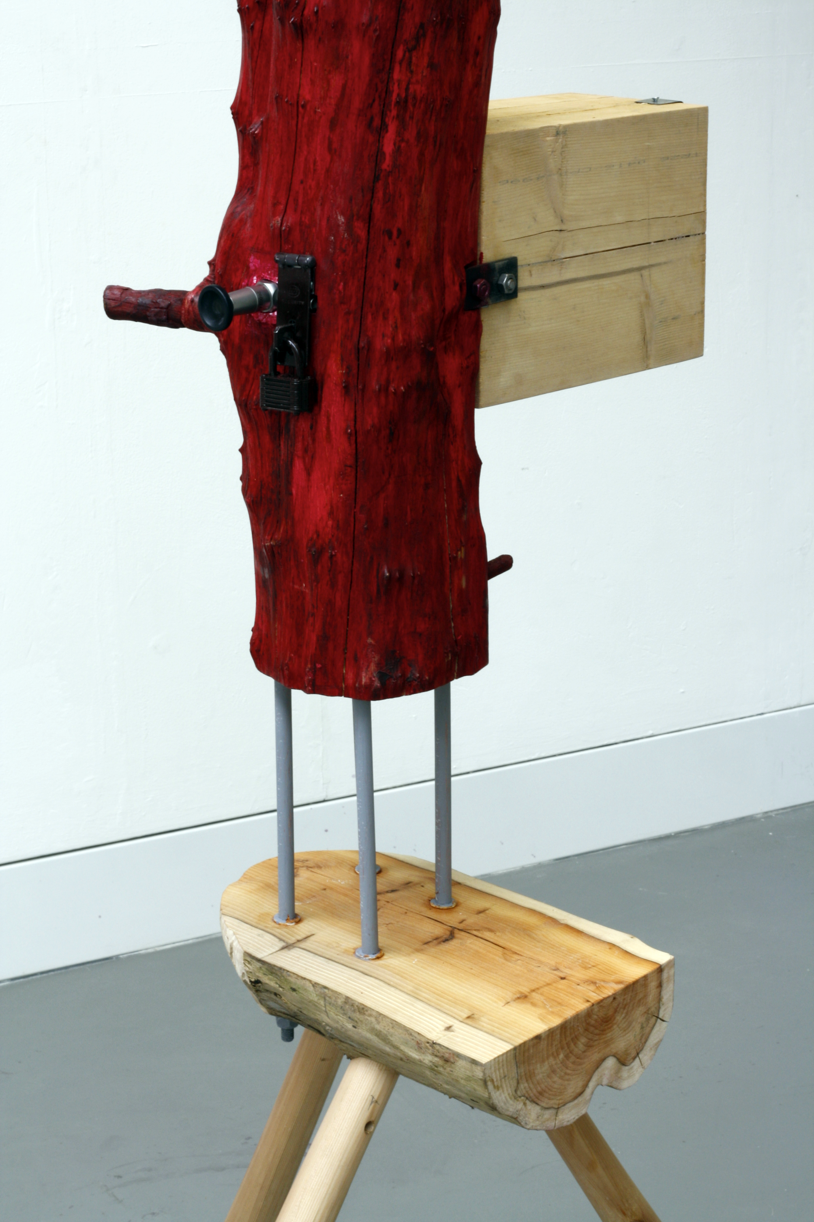
Figure 2 Matter and Memory, detail
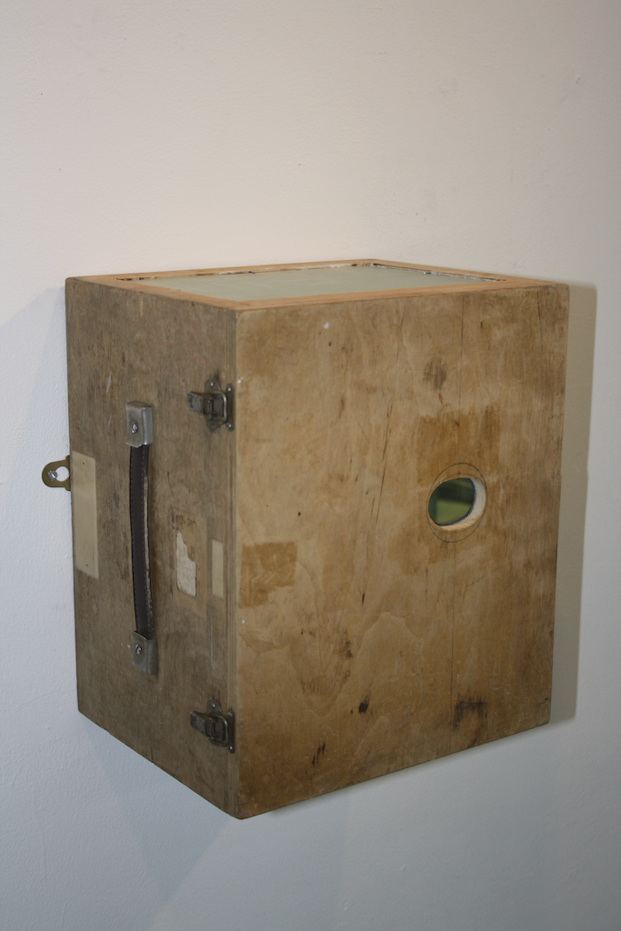
Figure 3 Family Tree
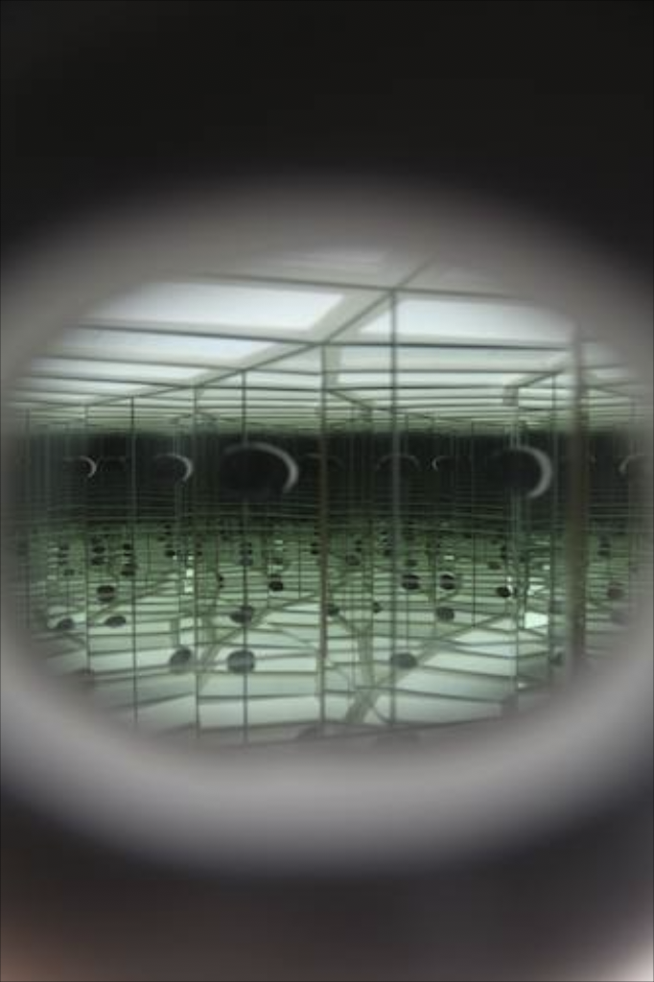
Figure 4 Family Tree, view through the eye piece

