Data S1: Sensitivity analysis of Gaussian Trend Surface models
Concerns associated with Trend Surface Analysis are well established particularly with the use of higher order surfaces, with boundary issues (predictions near and beyond the limits of the data set) and where the data is clustered or auto-correlated (e.g. Robinson, 1970). An ideal data set would consist of independent data points with a random margin of error evenly spread across the area of study. In contrast the distribution of shoreline fragments is far from evenly spread and is frequently clustered. The division of long shoreline fragments into sub-fragments results in auto-correlation and as a consequence the Coefficient of Determination (R²) will be enhanced. It must however be remembered that the trend surface analysis is not being used to confirm the correlation of the shoreline fragments, rather it is being used to try and identify the zone of greatest displacement which lies within the heart of the data set. Similarly restricting the analysis to the low order quadratic surface provides a generalised model of displacement. An analysis of the residuals associated with the model will highlight where there is a poor fit to the data and where more complex patterns of displacement are likely to be found. It is however recognised that the centre of uplift and the orientation of the dome could be influenced by the zero value selected in the Gaussian model, the correction factors applied to standardise the data to palaeo-RSL, clustering of data points and the distribution of the points. The potential variation in altitude of individual data points associated with ‘errors of measurement’ (indicative range) could also influence the results of the analysis. The impact of each of these factors was assessed for each shoreline by undertaking sensitivity analysis, and the detailed results are provided below.

2.0 Variations in the Zero value selected
For each shoreline the zero value was calculated to two decimal points by maximising the Coefficient of Determination (R² – calculated to nine decimal places) and the centre and orientation of the dome was determined. Alternative zero values were then input into the model and the change in the centre and orientation noted. An alternative approach would have been to use the predicted ice-equivalent (eustatic) sea level when the shoreline was formed so zero values up to the ice-equivalent (eustatic) sea level were calculated. A plot showing how the location of the centre changes with the zero value has also been produced.
Main Lateglacial Shoreline
Zero Value | R² | Centre of Dome Easting (km) | Centre of Dome Northing (km) | Distance from R² Max (km) | Orientation of Dome (degrees) | Difference from R² Max (degrees) | Comment
-20.5 | 0.877488053 | 217.02 | 735.3 | 0.463249 | 8.27 | 3.01
-21 | 0.918819045 | 216.92 | 735.23 | 0.522015 | 7.31 | 2.05
-22 | 0.94430569 | 217 | 735.16 | 0.4245 | 6.33 | 1.07
-23 | 0.951570906 | 217.18 | 735.11 | 0.237697 | 5.75 | 0.49
-24 | 0.953365634 | 217.37 | 735.06 | 0.041231 | 5.34 | 0.08
-24.21 | 0.953406935 | 217.41 | 735.05 | 0 | 5.26 | 0 | R² Max
-25 | 0.952965828 | 217.57 | 735.01 | 0.164924 | 5.02 | -0.24
-26 | 0.951583166 | 217.76 | 734.98 | 0.356931 | 4.76 | -0.5
-27 | 0.949751907 | 217.95 | 734.94 | 0.55109 | 4.55 | -0.71
-28 | 0.947732488 | 218.12 | 734.91 | 0.723671 | 4.37 | -0.89
-29 | 0.945659533 | 218.29 | 734.87 | 0.89822 | 4.21 | -1.05
-30 | 0.943604668 | 218.44 | 734.85 | 1.049238 | 4.07 | -1.19
-40 | 0.927311886 | 219.6 | 734.65 | 2.22623 | 3.26 | -2
-50 | 0.917434596 | 220.3 | 734.55 | 2.932934 | 2.88 | -2.38
-63 | 0.909504695 | 220.88 | 734.47 | 3.518139 | 2.6 | -2.66 | Ice -equivalent (eustatic) sea level estimated when shoreline formed
Table DF1.1 – Variations in the centre and orientation of the displacement dome associated with the Main Lateglaical Shoreline.
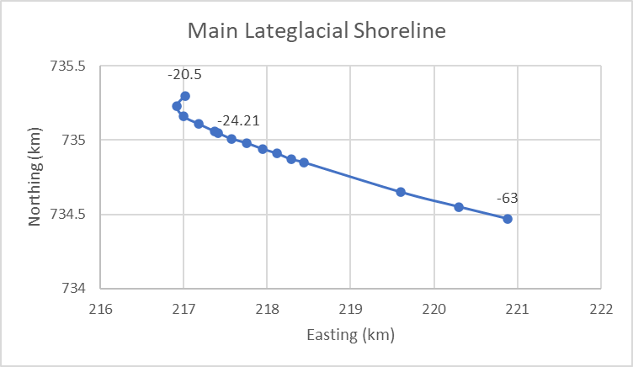
Figure DF1.1: The variation in the location of the centre of displacement associated with the Main Lateglacial Shoreline as the Zero Value is altered in the Gaussian Quadratic Trend Surface Analysis.

Menteith Shoreline
Zero Value | R2 | Centre of Dome Easting (km) | Centre of Dome Northing (km) | Distance from R2 Max (km) | Orientation of Dome (degrees) | Difference from R2 Max (degrees) | Comment
-2.8 | 0.951748551 | 234.83 | 699.89 | 3.087539 | 22.37 | 3.16
-3 | 0.960987889 | 235.48 | 701.27 | 1.67863 | 20.94 | 1.73
-3.2 | 0.96454102 | 235.55 | 702.14 | 0.835225 | 20.02 | 0.81
-3.46 | 0.965702278 | 235.31 | 702.94 | 0 | 19.21 | 0 | R2 Max
-3.6 | 0.965482556 | 235.12 | 703.28 | 0.389487 | 18.87 | -0.34
-3.8 | 0.964579299 | 234.79 | 703.69 | 0.912634 | 18.48 | -0.73
-4 | 0.963229996 | 234.43 | 704.03 | 1.400893 | 18.17 | -1.04
-4.5 | 0.958864939 | 233.4 | 704.69 | 2.590483 | 17.61 | -1.6
-5 | 0.953958793 | 232.58 | 705.17 | 3.525025 | 17.26 | -1.95
-6 | 0.944192609 | 230.86 | 705.83 | 5.306091 | 16.89 | -2.32 | Ice -equivalent (eustatic) sea level estimated when shoreline formed
Table DF1.2 – Variations in the centre and orientation of the displacement dome associated with the Menteith Shoreline.

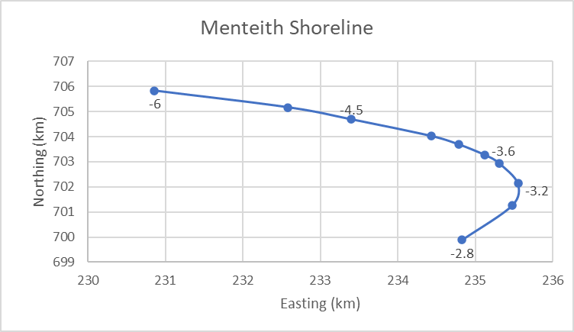
Figure DF1.2: The variation in the location of the centre of displacement associated with the Menteith Shoreline as the Zero Value is altered in the Gaussian Quadratic Trend Surface Analysis.

Blairdrummond Shoreline
Zero Value | R2 | Easting (km) | Northing (km) | Distance from R2 Max (km) | Orientation of Dome (degrees) | Difference from R2 Max (degrees) | Comment
0 | 0.96115239 | 242.45 | 702.53 | 3.331426 | 7.2 | -8.37
-0.4 | 0.966524133 | 241.27 | 701.99 | 2.03686 | 10.9 | -4.67
-0.8 | 0.968480196 | 240.31 | 701.63 | 1.011929 | 13.39 | -2.18
-1 | 0.968871117 | 239.89 | 701.48 | 0.566127 | 14.37 | -1.2
-1.2 | 0.969031522 | 239.51 | 701.36 | 0.167631 | 15.22 | -0.35
-1.29 | 0.969047642 | 239.35 | 701.31 | 0 | 15.57 | 0 | R2 max
-1.4 | 0.969029802 | 239.16 | 701.25 | 0.199249 | 15.96 | 0.39
-1.6 | 0.968912245 | 238.53 | 701.06 | 0.857263 | 17.21 | 1.64 | Ice -equivalent (eustatic) sea level estimated when shoreline formed
Table DF1.3 – Variations in the centre and orientation of the displacement dome associated with the Blairdrummond Shoreline.

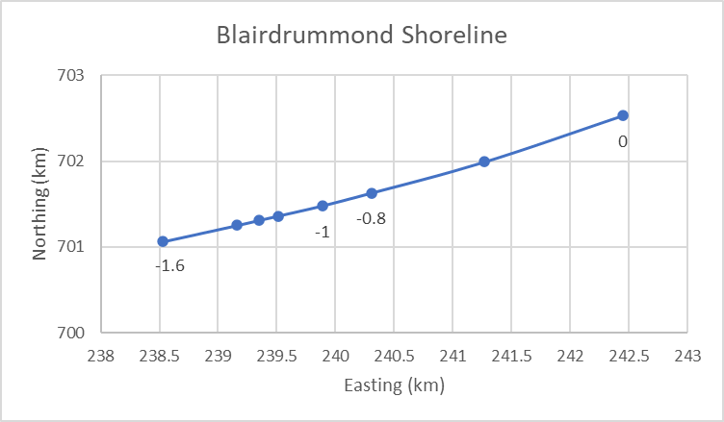
Figure DF1.3: The variation in the location of the centre of displacement associated with the Blairdrummond as the Zero Value is altered in the Gaussian Quadratic Trend Surface Analysis.

Wigtown Shoreline
Zero Value | R2 | Easting (km) | Northing (km) | Distance from R2 Max (km) | Orientation of Dome (degrees) | Difference from R2 Max (degrees) | Comment
-0.21 | 0.919910931 | 239.36 | 681.36 | 2.928361 | 26.4 | 1.43
-0.22 | 0.925493728 | 238.59 | 680.25 | 1.578005 | 25.86 | 0.89
-0.23 | 0.927470864 | 238.16 | 679.66 | 0.848116 | 25.5 | 0.53
-0.24 | 0.928169041 | 237.87 | 679.28 | 0.370135 | 25.21 | 0.24
-0.25 | 0.928261743 | 237.64 | 678.99 | 0 | 24.97 | 0 | R2 max
-0.26 | 0.928025974 | 237.46 | 678.77 | 0.284253 | 24.77 | -0.2
-0.28 | 0.927052539 | 237.18 | 678.45 | 0.709366 | 24.43 | -0.54
-0.3 | 0.925769776 | 236.97 | 678.22 | 1.020686 | 24.15 | -0.82
-0.4 | 0.918757128 | 236.31 | 677.66 | 1.880904 | 23.18 | -1.79
-0.5 | 0.912576859 | 235.92 | 677.45 | 2.308679 | 22.57 | -2.4 | Ice -equivalent (eustatic) sea level estimated when shoreline formed
Table DF1.4 – Variations in the centre and orientation of the displacement dome associated with the Wigtown Shoreline.

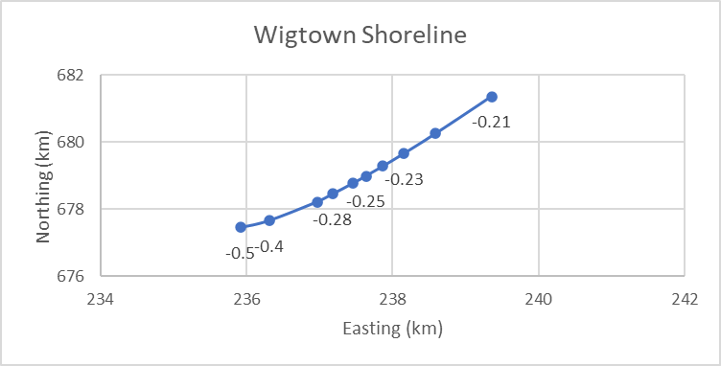
Figure DF1.4: The variation in the location of the centre of displacement associated with the Wigtown Shoreline as the Zero Value is altered in the Gaussian Quadratic Trend Surface Analysis.

Changes to the zero value of 0.1 altered the centre of the dome by less than 1 km. An alternative approach was to set the zero to the ice volume equivalent (eustatic) sea level at the time the shoreline formed. This increased the displacement of the centre to 1.4-5.3 km. This approach was however discounted given the shorelines are considered to be diachronous and so different zero values should be applied to the centre and edges of the dome.

- Morphological Correction Factors
Whilst the majority of the shoreline fragments are considered to have formed at MHWST the Holocene features from the inner Clyde and Loch Lomond had a reference water level below MHWS. Alternative scenarios were modelled with different reference water levels being utilised. This also illustrated the impact of altering the altitude of index points for the region closest to the centre of the dome. The centre of the dome moved by 1.3 km.
Shoreline | R² | Zero Value | Easting (km) | Northing (km) | Distance from adopted model (km) | Orientation (degrees) | Change from adopted model (degrees) | Nature of Change
Menteith Shoreline | 0.96706244 | -3.75 | 235.97 | 703.31 | 0.756637298 | 18.34 | -0.87 | Morphological adjustments for inner Clyde and Loch Lomond standardised to MHWST-1.07.
Blairdrummond Shoreline | 0.96703799 | -1.03 | 239.21 | 701.87 | 0.577234788 | 15.26 | -0.31
Wigtown Shoreline | 0.9342389 | -0.45 | 237.76 | 680.26 | 1.275656694 | 25.52 | 0.55
Menteith Shoreline | 0.96651472 | -3.74 | 235.82 | 703.23 | 0.586685606 | 18.41 | -0.8 | Morphological adjustments for Loch Lomond standardised to MHWST-1.2
Blairdrummond Shoreline | 0.96409995 | -0.94 | 240.54 | 702.06 | 1.406627172 | 14.49 | -1.08
Table DF1.5 – Variations in the centre and orientation of the displacement dome associated with alternative morphological adjustments to the Reference Water Level of shoreline fragments in the inner Clyde and Loch Lomond Basin regions..
- Clustering
The number of data points associated with each shoreline was reduced down to 18-23% of the original number. Shoreline fragments from a particular region or a string of 8-10 fragments along a particular section of coastline were combined to produce an average altitude and location. The reduction focused on regions where there was a large number of shoreline fragments (e.g. west coast for the Main Lateglacial Shoreline). The Wigtown Shoreline was the most susceptible to this change (centre moved 7.9 km) with the others moving less than 3.5 km.
Shoreline | R² | Zero Value | Easting (km) | Northing (km) | Distance from adopted centre (km) | Orientation (degrees) | Change from adopted model (degrees) | No of original data points | No of Revised Data Points | % of original data points
Main Lateglacial Shoreline | 0.972202 | 25.86 | 217.17 | 734.87 | 0.30 | 9.8223157 | 2.47 | 413 | 75 | 18.15981
Menteith Shoreline | 0.982777 | -3.45 | 238.46 | 701.68 | 3.3926538 | 20.21 | 1 | 195 | 36 | 18.46154
Blairdrummond Shoreline | 0.971657 | -1.25 | 237.51 | 698.57 | 3.3004848 | 16.28 | 0.71 | 236 | 45 | 19.0678
Wigtown Shoreline | 0.931423 | -0.48 | 234.2 | 671.88 | 7.8984619 | 26.21 | 1.24 | 135 | 33 | 24.44444
Main Lateglacial Shoreline | 0.971447 | 25.67 | 217.63 | 735.44 | 0.45 | 8.41572275 | 2.47 | 413 | 94 | 22.76029
Menteith Shoreline | 0.979645 | -3.39 | 237.99 | 702.94 | 2.68 | 19.63 | 0.42 | 195 | 48 | 35.55556
Blairdrummond Shoreline | 0.973689 | -1.09 | 238.6 | 699.29 | 2.154739 | 16.04 | 0.47 | 236 | 60 | 25.42373
Wigtown Shoreline | 0.932669 | -0.48 | 235.11 | 673.76 | 5.8098021 | 25.75 | 0.78 | 135 | 42 | 31.11111
Table DF1.6 – Variations in the centre and orientation of the displacement dome associated with de-clustered data sets for each shoreline.
The nature of the reduction of index points is illustrated below for each shoreline. revised isobases have only been produced for the Main Lateglacial Shoreline.

The percentage relates to the % of data points remaining for each shoreline so 18% indicates 82% of the original index points have been combined.
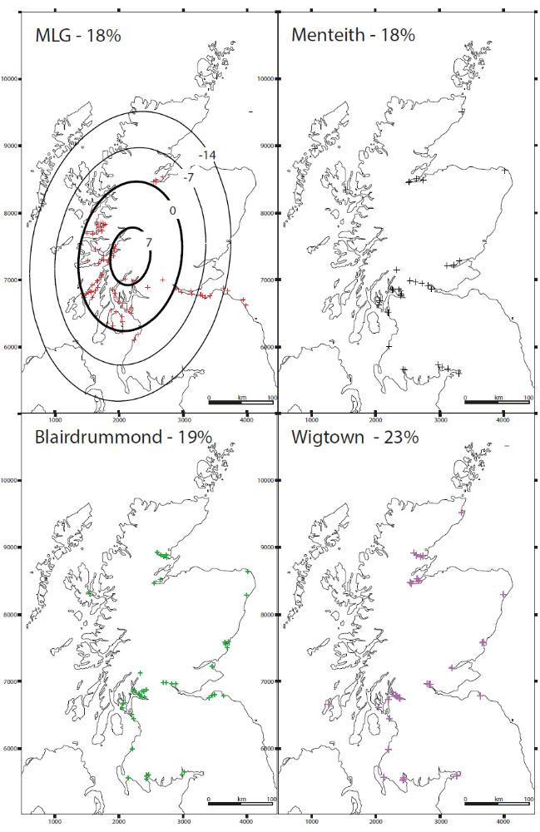
Figure DF1.5: Distribution of reduced index points associated each shoreline. The percentages indicate the % of index points used in the reduced model.

- Data distribution
A hypothetical data set of 100 points associated with an N-S orientated dome was created which had a more even distribution of data points with some clustering. The number of data points was then systematically reduced by removing data from selected areas (Table DF1.7). Reduced data sets which illustrated the data distribution of each shoreline were also produced (Table DF1.7, Figure DF1.6). The centre of the dome shifted by less than 2.1km and indicates that the distribution of the data points has a minimal impact on the centre of the displacement dome.
Shoreline | R² | Zero Value | Easting (km) | Northing (km) | Distance from preferred centre (km) | Orientation (degrees) | Change from preferred model (degrees)
Full 100 points | 0.992031715 | 16.53 | 216.12 | 738.34 | 0.00 | 4.76 | 0
49 pts (NE & SE removed, and de-clustering) | 0.994558713 | 13.28 | 215.8 | 737.92 | 0.53 | 4.73 | -0.03
41 pts (NE&N removed) | 0.993784185 | 12.81 | 216.3 | 738.25 | 0.20 | 5.58 | 0.82
38 pts (NE, N & S removed) | 0.993246783 | 12.72 | 216.31 | 738.49 | 0.24 | 5.59 | 0.83
33 pts (NE, N, S & Outer MF removed) | 0.990391757 | 14.66 | 216.58 | 736.94 | 1.47 | 4.93 | 0.17
31 pts (MLG equ) | 0.990378874 | 15.68 | 215.1 | 737.95 | 1.09 | 2.95 | -1.81
34 pts (Menteith equ) | 0.989809076 | 17.79 | 217.59 | 736.96 | 2.02 | 5.92 | 1.16
17 pts (Wigtown equ) | 0.996471041 | 14.18 | 216.81 | 737.27 | 1.27 | 4.17 | -0.59
Table DF1.7. Variations in the centre and orientation of the displacement dome associated with a hypothetical data set.

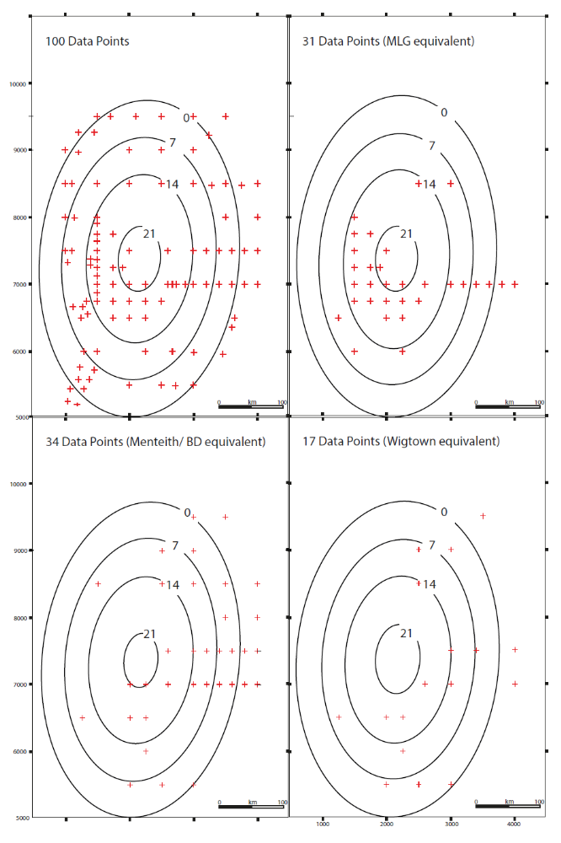
Figure DF1.6. The distribution of index points and Gaussian Quadratic Trend Surface isobase models for the hypothetical data set (100 index points). A reduced number of data points to reflect the Main Lateglacial (MLG), Menteith/Blairdrummond (BD) and Wigtown Shoreline distributions were also produced with no change in the altitude of the selected index points.

6.0 Potential Data Errors
The sensitivity of the model to potential errors associated with the index points (e.g. measurement error, reference water level incorrect, local MHWST at a different level to the nearest tidal station) was tested by utilising the indicative range values which varied by shoreline and site (±0.85 - ±0.12). Uniform changes (e.g. all index points increased/decreased by the indicative range) produced minimal changes (Table DF1.8), even though the scale of the change varied from region to region. Such uniform changes simulate the possible impact of variations in tidal range through time.

In contrast other systematic changes (e.g. east coast index points increased, west coast points reduced) produced significant changes (20-30km shifts in the centre of the dome) for the Holocene shorelines (Table DF1.9). It is however noteworthy that these changes are orientated in a NE-SW band (Fig.DF1.7). Changes of this nature currently have an unknown origin. In addition the errors illustrated by the indicative range are more likely to be randomly distributed, so applying the full value in a systematic way is an extreme evaluation of the model. As a consequence systematic variations associated with a quarter of the indicative range were also produced (Table DF1.10) and these indicated that the Wigtown shoreline was the most sensitive feature with the centre being displaced by 7.3 km but the other shorelines were displaced by less than 4.5 km.
Shoreline | R² | Zero Value | Easting (km) | Northing (km) | Distance from adopted model (km) | Orientation (degrees) | Change from adopted model (degrees) | Nature of Change
Main Lateglacial Shoreline | 0.95327262 | -23.50 | 217.35 | 736.28 | 1.23 | 3.84 | -1.42 | All data points altered to measured value + indicative range
Menteith Shoreline | 0.96852588 | -3.29 | 234.5 | 702.92 | 0.810246876 | 17.89 | -1.32 | All data points altered to measured value + indicative range
Blairdrummond Shoreline | 0.9669404 | -1.2 | 237.33 | 701.56 | 2.035411506 | 16.91 | 1.34 | All data points altered to measured value + indicative range
Wigtown Shoreline | 0.92665403 | -0.1 | 237.72 | 678.93 | 0.1 | 25.08 | 0.11 | All data points altered to measured value + indicative range
Main Lateglacial Shoreline | 0.9530726 | -24.92 | 217.46 | 733.88 | 1.17 | 6.69 | 1.43 | All data points altered to measured value - indicative range
Menteith Shoreline | 0.96452101 | -4.20 | 237.39 | 703.7 | 2.214497686 | 18.8 | -0.41 | All data points altered to measured value - indicative range
Blairdrummond Shoreline | 0.97033648 | -1.41 | 241.41 | 700.96 | 2.089521476 | 14.21 | -1.36 | All data points altered to measured value - indicative range
Wigtown Shoreline | 0.93683662 | -0.81 | 240.23 | 681.55 | 3.641661709 | 25.37 | 0.4 | All data points altered to measured value - indicative range
Table DF1.8. The variations in the location and orientation of the displacement dome of individual shorelines when there is a uniform change in the altitude of the shoreline fragments (altitude + or - indicative range).

Shoreline | R² | Zero Value | Easting (km) | Northing (km) | Distance from adopted model (km) | Orientation (degrees) | Change from adopted model (degrees) | Nature of Change
Main Lateglacial Shoreline | 0.95327262 | -23.50 | 217.35 | 736.28 | 1.23 | 3.84 | -1.42 | All data points altered to measured value + indicative range
Menteith Shoreline | 0.96852588 | -3.29 | 234.5 | 702.92 | 0.810246876 | 17.89 | -1.32 | All data points altered to measured value + indicative range
Blairdrummond Shoreline | 0.9669404 | -1.2 | 237.33 | 701.56 | 2.035411506 | 16.91 | 1.34 | All data points altered to measured value + indicative range
Wigtown Shoreline | 0.92665403 | -0.1 | 237.72 | 678.93 | 0.1 | 25.08 | 0.11 | All data points altered to measured value + indicative range
Main Lateglacial Shoreline | 0.9530726 | -24.92 | 217.46 | 733.88 | 1.17 | 6.69 | 1.43 | All data points altered to measured value - indicative range
Menteith Shoreline | 0.96452101 | -4.20 | 237.39 | 703.7 | 2.214497686 | 18.8 | -0.41 | All data points altered to measured value - indicative range
Blairdrummond Shoreline | 0.97033648 | -1.41 | 241.41 | 700.96 | 2.089521476 | 14.21 | -1.36 | All data points altered to measured value - indicative range
Wigtown Shoreline | 0.93683662 | -0.81 | 240.23 | 681.55 | 3.641661709 | 25.37 | 0.4 | All data points altered to measured value - indicative range
Shoreline | R² | Zero Value | Easting | Northing | Distance from adopted model (km) | Orientation (degrees) | Change from adopted model (degrees) | Nature of Change
Main Lateglacial Shoreline | 0.95593067 | -24.93 | 213.15 | 733.23 | 4.63 | 1.61 | -3.65 | West Coast + indicative range, East coast - indicative range
Menteith Shoreline | 0.96172613 | -3.33 | 226.2 | 694.11 | 12.68704063 | 19.4 | 0.19 | West Coast + indicative range, East coast - indicative range
Blairdrummond Shoreline | 0.97091215 | -1.37 | 224.13 | 691.07 | 18.34409987 | 17.24 | 1.67 | West Coast + indicative range, East coast - indicative range
Wigtown Shoreline | 0.92144801 | 0.12 | 223.38 | 655.59 | 27.4026933 | 24.63 | -0.34 | West Coast + indicative range, East coast - indicative range
Main Lateglacial Shoreline | 0.94962078 | -23.47 | 222.26 | 737.42 | 5.40 | 9.6 | 4.34 | West coast - indicative range, East coast + indicative range
Menteith Shoreline | 0.97040978 | -4.13 | 244.3 | 712.12 | 12.84883263 | 17.49 | -1.72 | West coast - indicative range, East coast + indicative range
Blairdrummond Shoreline | 0.96456325 | -1.23 | 252.73 | 711.97 | 17.10730838 | 14.36 | -1.21 | West coast - indicative range, East coast + indicative range
Wigtown Shoreline | 0.91810967 | -0.62 | 254.05 | 705.64 | 31.29713405 | 24.21 | -0.76 | West coast - indicative range, East coast + indicative range
Main Lateglacial Shoreline | 0.95601483 | -25.2 | 214.96 | 743.61 | 8.90 | 1.75 | -3.51 | Data points north of modelled centre + indicative range, South of centre - indicative range
Menteith Shoreline | 0.9695593 | -4.34 | 233.76 | 711.29 | 8.492643876 | 20.31 | 1.1
Blairdrummond Shoreline | 0.95617303 | -1.29 | 239.48 | 710.37 | 9.060932623 | 18.01 | 2.44
Wigtown Shoreline | 0.92161303 | -0.8 | 255.38 | 707.74 | 33.78268935 | 24.73 | -0.24
Main Lateglacial Shoreline | 0.94704272 | -23.1 | 219.53 | 728.39 | 6.99 | 9.6 | 4.34 | Data Points north of modelled centre - indicative range, Points south of centre + indicative range
Menteith Shoreline | 0.95593298 | -3.44 | 240.37 | 695.74 | 8.800204543 | 15.83 | -3.38
Blairdrummond Shoreline | 0.97560256 | -1.34 | 239.88 | 693.16 | 8.167214948 | 13.14 | -2.43
Wigtown Shoreline | 0.93573246 | -0.13 | 224.95 | 659.7 | 23.08982893 | 24.62 | -0.35
Wigtown Shoreline | 0.92652009 | -0.61 | 233.75 | 692.4 | 13.9628149 | 23.68 | -1.29 | Data points NW of modelled centre + indicative range, SE of centre - indicative range
Wigtown Shoreline | 0.91169843 | 0.11 | 241.29 | 666.2 | 13.30062405 | 27.24 | 2.27 | Data points NW of modelled centre - indicative range, SE of centre + indicative range
Table DF1.9. The variations in the location and orientation of the displacement dome of individual shorelines when there is a systematic change in the altitude of the shoreline fragments with one section of data being increased by the indicative range and the other decreased.

Shoreline | R² | Zero Value | Easting (km) | Northing (km) | Distance from adopted model (km) | Orientation (degrees) | Change from adopted model (degrees) | Nature of Change
Main Lateglacial Shoreline | 0.95414095 | -24.39 | 216.3 | 734.55 | 1.22 | 4.29 | -0.97 | West coast increased by indicative range/4. East coast decreased by indicative range/4
Menteith Shoreline | 0.96478661 | -3.43 | 232.67 | 700.81 | 3.392123229 | 19.43 | 0.22
Blairdrummond Shoreline | 0.96972712 | -1.31 | 235.76 | 698.69 | 4.444378472 | 15.93 | 0.36
Wigtown Shoreline | 0.92933576 | -0.15 | 233.69 | 672.44 | 7.648856124 | 25.24 | 0.27
Main Lateglacial Shoreline | 0.95258782 | -24.03 | 218.57 | 735.58 | 1.28 | 6.28 | 1.02 | West coast decreased by indicative range/4. East coast increased by indicative range/4
Menteith Shoreline | 0.96649232 | -3.5 | 237.89 | 705.1 | 3.364817974 | 18.95 | -0.26
Blairdrummond Shoreline | 0.96820385 | -1.28 | 242.79 | 703.95 | 4.336265675 | 15.25 | -0.32
Wigtown Shoreline | 0.92642263 | -0.34 | 241.88 | 685.08 | 7.420626658 | 24.89 | -0.08
Main Lateglacial Shoreline | 0.95410605 | -24.46 | 216.85 | 737.01 | 2.04 | 4.3 | -0.96 | North coast increased by indicative range/4. South coast decreased by indicative range/4
Menteith Shoreline | 0.96687768 | -3.54 | 234.65 | 704.78 | 1.954788991 | 19.85 | 0.64
Blairdrummond Shoreline | 0.96652797 | -1.29 | 239.31 | 703.48 | 2.170368632 | 16.2 | 0.63
Wigtown Shoreline | 0.92714666 | -0.33 | 241.28 | 685.36 | 7.336654551 | 25.15 | 0.18
Main Lateglacial Shoreline | 0.95246321 | -23.96 | 217.96 | 733.2 | 1.93 | 6.28 | 1.02 | North coast decreased by indicative range/4. South coast increased by indicative range/4
Menteith Shoreline | 0.964272 | -3.39 | 236.11 | 701.15 | 1.960637651 | 18.56 | -0.65
Blairdrummond Shoreline | 0.97117398 | -1.3 | 239.42 | 699.19 | 2.121155346 | 14.96 | -0.61
Wigtown Shoreline | 0.92876969 | -0.16 | 234.43 | 673.29 | 6.541719957 | 24.97 | 0
Table DF1.10. The variations in the location and orientation of the displacement dome of individual shorelines when there is a systematic change in the altitude of the shoreline fragments with one section of data being increased by the indicative range/4 and the other decreased by the indicative range/4

The overall variation of the centre of displacement for each shoreline is illustrated in Figure DF1.7.

Figure DF1.7. Spread of the centre of the Gaussian Trend surface model for each shoreline when key parameters are varied and the influence of potential known/unknown errors associated with the data set. Dots indicate the centres of uplift derived from current Gaussian Trend Surface models. Crosses represent alternative centres of uplift when key factors are adjusted. Note the spread of points is associated with a NE-SW aligned ellipse for the Holocene shorelines.
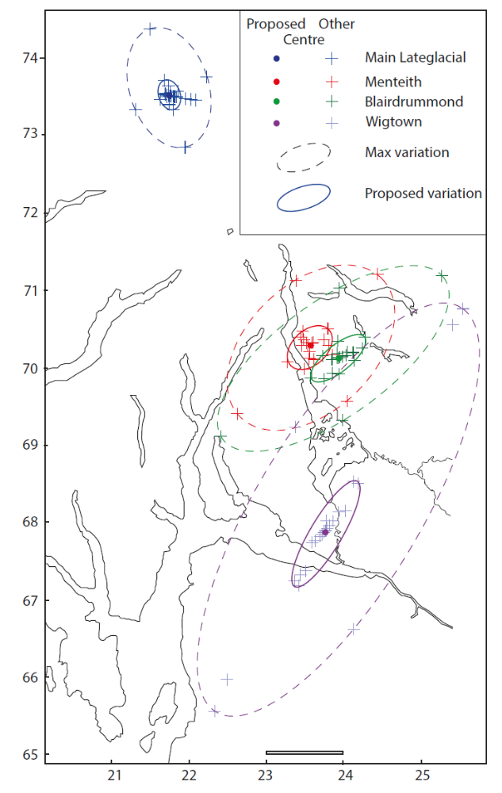

7.0 Overall
The sensitivity analysis indicated that the zero value, clustering, morphological correction factors for the Clyde/Loch Lomond region and distribution of the data points had limited impact on the location and orientation of the zone of maximum displacement (centre located within ± 8 km or less and orientation within ±3°). In contrast, if the data set contains unknown systematic errors the modelled centre could be incorrect by 7-33km for the Wigtown shoreline, 3-17km for the Menteith and Blairdrummond shorelines and 1.9-9km for the Main Lateglacial Shoreline. The largest systematic errors are considered unlikely and a smaller spread of values illustrated by lower systematic errors is considered more appropriate.

