Tim Long Output 2

Two drawings from the series ‘What Can A Body Be?’
To be Cross-Referred to Sub-Panel 34: Art & Design – History, Practice & Theory

Research Narrative:
Field of research
The subjectile in art can be seen to present aspects of the subject that are problematic, paradoxical and occasionally alarming. Antonin Artaud’s subjectile has been theorised by Jaques Derrida as a manifestation of a particular subjective difficulty that accounts for fundamental divisions in the subject’s nature and integrity. The subjectile suggests that split-up parts of the subject may become re-organised with objects. Julia Kristeva argues that Artaud and other early modernist artists established a mode of creative production that accesses properties that emanate from the pre-Oedipal period that is held by Freud to pre-date the social, ‘normalised’ subject. The subjectile can be seen as a mode of creative sensibility that accommodates the power of objects in art within the subject.
Context
In 2008 I exhibited two drawings from a series titled What Can A Body Be? which rigorously pursued, through analogue and digital montage techniques how the human form can be integrated with objects by specifically challenging the visual integrity of the human figure. The human figures depicted in these drawings examined how montage techniques employing found, hand-drawn and digital elements can be combined to present hybrid figures made from disparate features.
Innovation
The drawings explore the power that grotesque forms and images can have on the imagination, and how the theory of the subjectile can be effectively elaborated through artistic invention that explores alternative depictions of the human form. Since the drawings depict the human form actually integrated with objects, the relationship between subject and object is literally articulated. The works encouraged associations between subject and object, and contribute to a long tradition of hybrid depictions of the human form, from Arcimboldo to Max Ernst and Louise Bourgeois. My technique in these works also enabled the work to be produced through hybrid techniques, that embrace hand-drawn and digital techniques. (Word Count: 425)

Indicators of Quality: Exhibited as part of the Royal Academy Summer Exhibition in June-August 2008. Work subject to a highly selective peer-review process by the Royal Academy. The theme of the Royal Academy's 2008 Summer Exhibition was ‘Man Made’. The works were featured on The Summer Exhibition: A Culture Show Special, 12 June, 2008 BBC2. More than 150,000 people visited the exhibition.
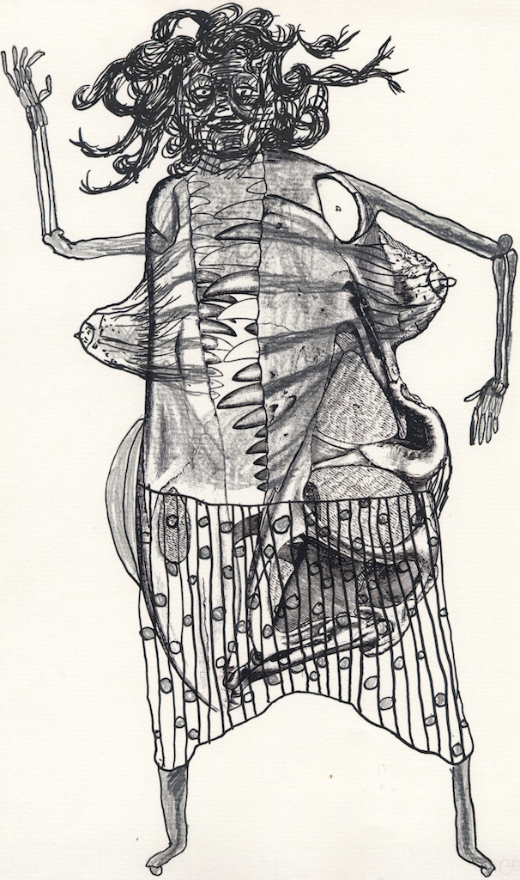
Figure 1 What can a body be? part of a series of drawings
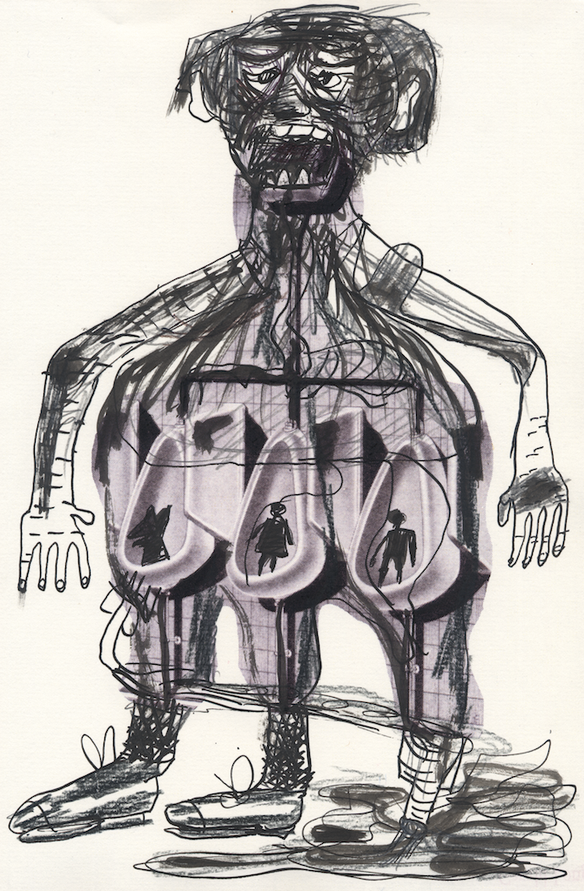
Figure 2 What can a body be? part of a series of drawings

