ancilleray resources

Understanding the changes of the human body and the impact of nutrition and physical activity on adults (40-59 years)

This ancillary resource provides suggestions of some of the following resources that are available mainly in open sources. It is aimed at providing an introduction to the key areas and contexts of the module and is not a comprehensive document. The use of other and additional resources to support the appropriate levels and contexts of the programmes and institutional access to resources is recommended.
Contents
NUTRITION 2
CHANGES OF THE HUMAN BODY 13
WEARABLE TECHNOLOGY 14
SAMPLE OF APPLICATIONS 16
PROGRAMME OF HEALTH ENHANCING PHYSICAL ACTIVITY BASED ON WALKING SPORTS 18
Scientific journals 18
Books 18
Walking sports: web pages 19

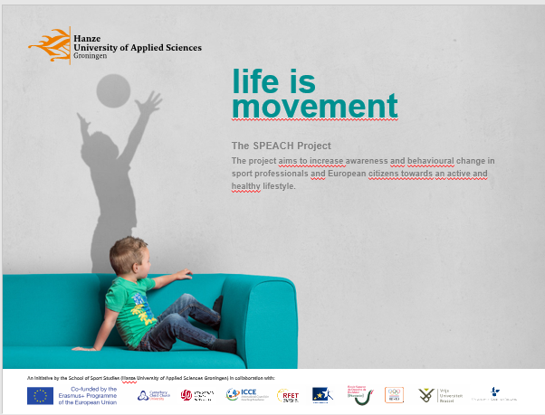

NUTRITION AND HEALTH ENHANCING PHYSICAL ACTIVITY
Levels 4-6
Manore, M. & Thompson, J. (2009) Sport Nutrition for Health and Performance. Champaign, Illinois: Human Kinetics.
http://www.humankinetics.com/products/all-products/sport-nutrition-for-health-and-performance---2nd-edition

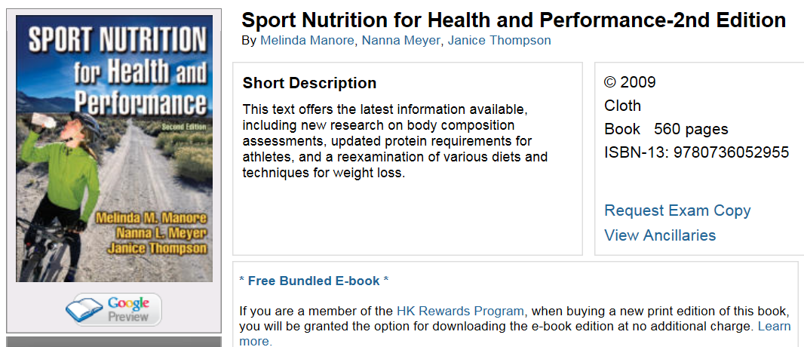

Sport Nutrition for Health and Performance, Second Edition, will help students and practitioners understand the function of the nutrients in the body and how these nutrients affect health and athletic performance. The authors present clear, comprehensive, and accurate nutrition information that may be applied to a variety of careers. The text provides students with practical knowledge in exercise and nutrition science, and it keeps practitioners on the cutting edge of current research and practices in the field.

Using the authors’ extensive backgrounds in nutrition, exercise physiology, and fitness, the text combines micronutrients into functional groupings to provide an easy framework for understanding how these nutrients can influence exercise performance and good health for both athletes and active individuals. This unique presentation allows readers to fully understand why proper nutrition helps athletes prevent injury, enhance recovery, improve daily workouts, and maintain optimal health and body weight.

This second edition has been thoroughly revised and updated to reflect the latest issues, guidelines, and recommendations for active individuals. Chapters dealing with macronutrients and micronutrients have been entirely rewritten, and all chapters have been revised to reflect the latest Dietary Reference Intakes, USDA Food Guide Pyramid, Food Pyramid for Athletes, Dietary Guidelines for Americans, and physical activity recommendations from various organizations, including the 2008 Physical Activity Guidelines by DHHS. Following are some of the current topics discussed in the text:
•Carbohydrate recommendations for athletes before, during, and after exercise

•Protein requirements of athletes based on the latest research

•Updated evaluation of the fat needs of athletes and the role of fat loading

•An evidence-based reexamination of various diets and techniques used for weight loss

•New research on body composition assessments and standards

•The latest on controversial nutrition issues such as the role of protein, vitamin D, and energy in bone health and new criteria for assessing bone health in young adults

•New nutrition and fitness assessments, questionnaires, and methods for measuring energy expenditure

•Updated information on various topics such as the issues of the active female, ergogenic aids, energy balance, and fluid balance

Sport Nutrition for Health and Performance, Second Edition, has also been improved with an attractive two-color format, new artwork, and a slimmer design that allows the text to maintain the content while reducing “backpack bulge.” The text also includes an online image bank that instructors may use to create customized PowerPoint presentations using artwork, tables, and figures from each chapter. In addition, a variety of features help readers comprehend the material presented, including chapter objectives, key concepts and key terms, additional information to learn more about a topic, and references. Chapter highlights provide in-depth information on topics and critically evaluate issues regarding myths and controversies in sport nutrition.

This book provides readers with clear, authoritative content that will help them understand the scientific basis of nutrition and make sound recommendations in their careers. With up-to-date content based on current guidelines, Sport Nutrition for Health and Performance, Second Edition, is an outstanding text for both students and practitioners concerned with achieving good health and maximizing performance.

Contents

Chapter 1. Introduction to Nutrition for Exercise and Health
Role of Nutrition in Exercise and Sport
Essential Nutrients and Dietary Recommendations
Role of Eating a Balanced Diet
Role of Nutrition and Exercise in Disease Prevention
Chapter in Review
Learning Aides

Chapter 2. Carbohydrate as a Fuel for Exercise
Function, Classification, and Dietary Sources of Carbohydrate
Carbohydrate Metabolism During Exercise
Carbohydrate Reserves and Dietary Intake
Carbohydrate Feeding Before Exercise
Carbohydrate Feeding During Exercise
Carbohydrate Feeding Postexercise and During Training Periods
Muscle Glycogen Supercompensation
Chapter in Review
Learning Aides

Chapter 3. Fat As a Fuel for Exercise
Function, Classification, and Dietary Sources of Fat
Body Fat Reserves and Dietary Fat Intake
Fat Metabolism During Exercise
Enhancement of Fat Oxidation
Dietary Fat Recommendations for Optimal Performance and Health
Chapter in Review
Learning Aides

Chapter 4. Protein and Exercise
Functions and Classifications
Methods of Assessing Protein Status
Dietary Sources of Protein
Metabolism of Protein During and After Exercise
Dietary Protein Recommendations for Active Individuals
Chapter in Review
Learning Aides

Chapter 5. Energy and Nutrient Balance
Energy and Macronutrient Balance Equations
Macronutrient Balance
Energy Expenditure
Energy Intake
Chapter in Review
Learning Aides

Chapter 6. Achieving Healthy Body Weight
Role of Diet and Exercise in Achieving a Healthy Body Weight
Weight Loss Interventions
Adding Exercise to Weight Loss Programs
Recommendations for Maintaining or Gaining Weight
Weight Concerns of Athletes
Chapter in Review
Learning Aides

Chapter 7. Body Composition
Body Composition and Health
Body Composition and Sport Performance
Body Composition Assessment Models and Methods
Accuracy of Body Composition Assessment Methods
Selection Criteria for Field Methods
Body Composition of Athletes
Body Composition Standards and Health
Chapter in Review
Learning Aides

Chapter 8. Fluid and Electrolyte Balance
Water and Electrolyte Balance
Fluid and Electrolyte Recommendations for Exercise
Sport Drinks and Fluid Replacement Beverages
Fluid Needs in Hot Environments
Fluid Needs in Cold Environments
Fluid and Electrolyte Needs for Children and Adolescents
Chapter in Review
Learning Aides

Chapter 9. B Vitamins Important in Energy Metabolism
Exercise-Related Functions and Dietary Requirements
Rationale for Increased Need for Active Individuals
Assessment of Vitamin Status
Exercise and Vitamin Requirements
Vitamins and Exercise Performance
Chapter in Review
Learning Aides

Chapter 10. Antioxidant Nutrients
Actions of Antioxidants
Enzymes Involved in Antioxidant Activities
Nutrients Involved in Antioxidant Activities
Assessment of Oxidative Damage
Rationale for Increased Antioxidant Need Among Active Individuals
Antioxidants and Chronic Diseases
Antioxidants and Performance
Chapter in Review
Learning Aides

Chapter 11. Minerals and Exercise
Exercise-Related Functions, Dietary Requirements, and Food Sources
Assessment of Mineral Status
Rationale for Increased Need for Active Individuals
Nutritional Status of Active People
Chapter in Review
Learning Aides

Chapter 12. Micronutrients Important in Blood Formation
Exercise-Related Functions, Dietary Requirements, and Food Sources
Rationale for Increased Need for Active People
Assessment of Vitamin and Mineral Status
Nutritional Status of Active Individuals
Chapter in Review
Learning Aides

Chapter 13. Nutrients for Bone Health
Review of Bone Metabolism
Calcium
Phosphorus
Magnesium
Vitamin D
Other Nutrients Involved in Bone Metabolism
Exercise and Bone Health
Chapter in Review
Learning Aides

Chapter 14. Nutrition and Fitness Assessment
Medical and Health History Questionnaires
Assessing Energy and Nutrient Intake
Assessing Daily Energy Expenditure
Fitness Assessment
Chapter in Review
Learning Aides

Chapter 15. Nutrition and the Active Female
Energy and Nutrient Requirements
Female Athlete Triad
Chapter in Review
Learning Aides

Chapter 16. Ergogenic Substances
Ergogenic Substances in Sport and Exercise
Evaluating Ergogenic Substances
Choosing Quality Ergogenic Substances
Review of Two Ergogenic Substances
Chapter in Review
Learning Aides

Appendix A. Nutritional Recommendations
Appendix B. Artificial Sweeteners and Fat Replacers
Appendix C. Energy Balance
Appendix D. Body Fat Percentages for Athletes
Appendix E. Nutrition and Fitness Assessment
Index
About the Authors
Audiences

Text for upper-undergraduate or graduate students in nutrition, exercise physiology, and kinesiology programs. Reference for fitness professionals, dietitians, health fitness specialists, and sports medicine specialists.

Product Description

Sport Nutrition, Second Edition, is also available as an e-book. The e-book is available at a reduced price and allows readers to highlight and take notes throughout the text. When purchased through the Human Kinetics site, access to the e-book is immediately granted when the order is received.

The new edition of Sport Nutrition: An Introduction to Energy Production and Performance presents the principles, background, and rationale for current nutrition guidelines specifically for athletes. Using a physiological basis, this text provides an in-depth look at the science behind sport nutrition. Students will come away with a comprehensive understanding of nutrition as it relates to sport and the influence of nutrition on exercise performance, training, and recovery.

The chapters and the material within each chapter are sequenced in a logical order that will help instructors deliver a better course and spend less time in preparing lectures and tutorials. Instructors will also enjoy the completely new ancillaries with this edition, including an online instructor guide, test package, PowerPoint presentation package, and image bank. This text contains updated and expanded information to keep students current on the latest findings in sport nutrition:
•A new chapter on training adaptations, including effects of nutrition on overtraining

•New information on weight management and body composition for athletes

•New research on carbohydrate and new recommendations for carbohydrate intake during training

•An expanded discussion on the role of protein in strength and endurance exercise training

•The latest information on exercise, nutrition, and immune function

The new content complements the strong foundational information that the authors provided in the previous edition, including fuel sources for muscle and exercise metabolism, energy requirements for various sports, and a complete grounding in the macronutrients (carbohydrate, fat, and protein) and the micronutrients (vitamins and minerals). With more than 200 illustrations, new highlight boxes, and tables and sidebars throughout the text, students will be able to more easily grasp the scientific concepts presented in this text. Each chapter also includes learning objectives, key terms, and key points to help readers retain the information. The text presents not only nutrition principles but also the exercise biochemistry involved and the energy needs of athletes. Readers will better understand how supplements may be used in an athlete’s diet, and they will learn how to separate fact from fallacy regarding the claims of the numerous nutritional supplements available today.

More than a simple prescription of recommendations, this second edition of Sport Nutrition features a unique presentation that facilitates readers’ understanding of the science supporting the nutrition recommendations. As a result, students will be prepared for advanced study and future careers, and professionals will gain the knowledge and confidence to provide sound advice to athletes.

Contents

Chapter 1. Nutrients
Function of Nutrients
Carbohydrate
Fat
Protein
Water
Vitamins, Minerals, and Trace Elements
Phytonutrients

Chapter 2. Nutrients and Recommended Intakes
Essential Nutrients
Development of Recommended Intakes
Current Recommended Intakes
Practical Guidelines for a Balanced Healthy Diet
Food Labels
Analyzing Dietary Intake

Chapter 3. Fuel Sources for Muscle and Exercise Metabolism
Subcellular Skeletal Muscle Structure
Force Generation in Skeletal Muscle
Fiber Types
Energy for Muscle Force Generation
Fuel Stores in Skeletal Muscle
Regulation of Energy Metabolism
Metabolic Responses to Exercise
Metabolic Adaptations to Exercise Training

Chapter 4. Energy
Energetic Efficiency
Measuring the Energy Content of Food
Measuring Energy Expenditure
Components of Energy Expenditure
Energy Balance

Chapter 5. Gastric Emptying, Digestion, and Absorption
Anatomy of the Gastrointestinal Tract
Regulation of the Gastrointestinal Tract
Digestion
Absorption
Function of Bacteria in the Colon
Regulation of Gastric Emptying
Gastrointestinal Problems During and After Exercise

Chapter 6. Carbohydrate
History
Role of Carbohydrate
Recommendations for Carbohydrate Intake
Carbohydrate Intake Days Before Competition
Carbohydrate Intake Hours Before Exercise
Carbohydrate Intake 30 to 60 Minutes Before Exercise
Carbohydrate During Exercise
Carbohydrate After Exercise

Chapter 7. Fat
Fat Metabolism During Exercise
Limits to Fat Oxidation
Fat as a Fuel During Exercise
Regulation of Carbohydrate and Fat Metabolism
Fat Supplementation and Exercise
Effect of Diet on Fat Metabolism and Performance

Chapter 8. Protein and Amino Acids
Amino Acids
Techniques to Study Protein and Amino Acid Metabolism
Protein Requirements for Exercise
Training and Protein Metabolism
Effect of Protein Intake on Protein Synthesis
Amino Acids as Ergogenic Aids
Protein Intake and Health Risks

Chapter 9. Water Requirements and Fluid Balance
Thermoregulation and Exercise in the Heat
Effects of Dehydration on Exercise Performance
Mechanisms of Heat Illness
Effects of Fluid Intake on Exercise Performance
Daily Water Balance
Fluid Requirements for Athletes

Chapter 10. Vitamins and Minerals
Water-Soluble and Fat-Soluble Vitamins
Recommended Intakes of Vitamins
Macrominerals and Microminerals
Recommended Intakes of Minerals
Critical Micronutrient Functions
Assessing Micronutrient Status
Exercise and Micronutrient Requirements
Ergogenic Effect of Micronutrient Supplementation
Recommendations for Micronutrient Intake in Athletes

Chapter 11. Nutrition Supplements
Nonregulation of Nutrition Supplements
Critical Evaluation of Nutrition Supplements Studies
Androstenedione
Bee Pollen
Beta Alanine and Carnosine
Beta-Hydroxy Beta Methylbutyrate
Boron
Caffeine
L-Carnitine
Choline
Chromium
Coenzyme Q10
Creatine
Dehydroepiandrosterone
Fish Oil
Ginseng
Glycerol
Inosine
Lactate Salts and Polylactate
Lecithin
Medium-Chain Triacylglycerol
Pangamic Acid
Phosphatidylserine
Phosphorus
Pyruvate (and Dihydroxyacetone)
Sodium Bicarbonate
Sodium Citrate
Vanadium
Wheat Germ Oil
Contamination of Nutrition Supplements

Chapter 12. Nutrition and Training Adaptations
Training Adaptations
Signal Transduction Pathways
Starting a Signaling Cascade
Secondary Signals
Nutrition Effects on Training Adaptations
Overtraining

Chapter 13. Body Composition
Optimal Body Weight and Composition
Body Composition Models
Normal Ranges of Body Weight and Body Fat

Chapter 14. Weight Management
Body Weight and Composition in Different Sports
Genetics
Energy and Macronutrient Intake
Regulation of Appetite
Effect of Exercise on Appetite
Physical Activity and Energy Expenditure
Dietary Weight-Loss Methods
Exercise for Weight Loss
Decreased Resting Metabolic Rate With Weight Loss
Weight Cycling
Gender Differences in Weight Loss
Practicalities of Weight Loss for Athletes
Defining the Strategy

Chapter 15. Eating Disorders in Athletes
Types of Eating Disorders
Prevalence of Eating Disorders in Athletes
Risk Factors
Effects of Eating Disorders on Sports Performance
Effects of Eating Disorders on the Athlete’s Health
Treatment and Prevention of Eating Disorders

Chapter 16. Nutrition and Immune Function in Athletes
Functions of the Immune System and Its Cellular Components
General Mechanism of the Immune Response
Effects of Exercise on the Immune System
Nutritional Manipulations to Decrease Immunodepression in Athletes
Mechanisms of Nutritional Influences on Immune Function in Athletes
Conclusions and Recommendations

Appendix A. Key Concepts in Biological Chemistry Relevant to Sport Nutrition
Appendix B. Unit Conversion Tables
Appendix C. Recommended Daily Allowances for North America
Appendix D. Reference Nutrient Intakes for the United Kingdom
Appendix E. Recommended Dietary Intakes for Australia
Glossary
References
Index
Audiences
Text for undergraduate introductory sport nutrition, exercise physiology, and sport science courses. Reference for sport nutritionists, dietitians, exercise and sport scientists, health and fitness instructors, physical educators, and coaches.

Sport Nutrition, Second Edition
Welcome to the ancillary website for Sport Nutrition, Second Edition.
http://www.humankinetics.com/sportnutrition2e

Instructor resources are free to course adopters and granted by your sales representative. To request access, contact your sales rep.
Some of these files are in Microsoft Office® formats. If you do not have software that allows you to open or view these files, free software is available for download at OpenOffice.org that will allow you to do so. Human Kinetics, Inc., is not affiliated with OpenOffice.org in any way.
Click here to learn more about the book.
Request an exam copy.
Find a sales representative.

Instructor Resources
E-Book

Test Package
Make your own tests and quizzes
Choose from hundreds of test questions
Instructor Guide
Sample syllabus
Lecture Outlines
Key Points
Lab Activities
Assignments
Readings
See a sample chapter

Image Bank
The image bank includes all of the figures, content photos, and tables from the text, sorted by chapter. Images can be used to develop a customized presentation based on specific course requirements.
Instructors can insert images from the image bank into the blank PowerPoint template provided, or into their own presentations.

Duan, Y., Brehm, W., Strobl, H., Tittlbach, S., Huang, Z., Si, G. (2013) Steps to and correlates of health-enhancing physical activity in adulthood: An intercultural study between German and Chinese individuals Journal of Exercise Science & Fitness 11 http://www.sciencedirect.com/science/article/pii/S1728869X1300035X

LEVEL 7

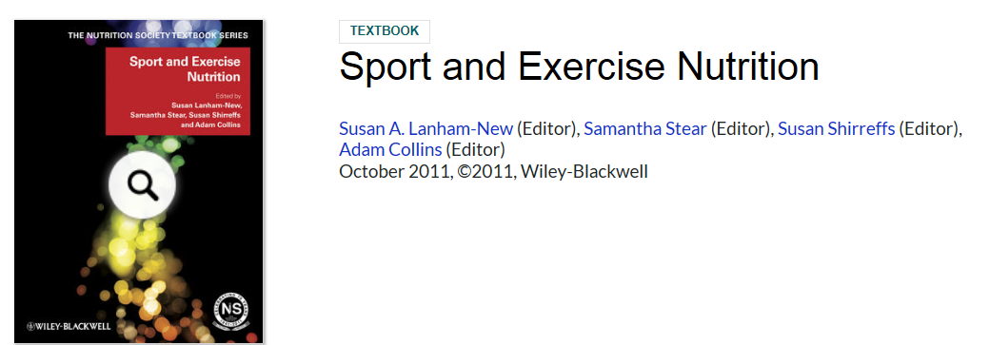
Description
Now widely adopted on courses throughout the world, the prestigious Nutrition Society Textbook series provides students with the scientific basics in nutrition in the context of a systems and disease approach rather than on a nutrient by nutrient basis. In addition books provide a means to enable teachers and students to explore the core principles of nutrition and to apply these throughout their training to foster critical thinking at all times.
This NS Textbook on Sport and Exercise Nutrition has been written to cover the latest information on the science and practice of sport and exercise nutrition. A key concept behind this textbook is that it aims to combine the viewpoints of world leading nutrition experts from both academia/research and a practical stand point. Plus where necessary there are additional practitioner based authors to ensure theory is translated into practice for each chapter in the form of either ‘practice tips' or ‘information sheets' at the end of relevant chapters.
The textbook in essence can be divided into three distinct but integrated parts:
- Part 1: covers the key components of the science that supports the practice of sport and exercise nutrition including comprehensive reviews on: nutrients both in general and as exercise fuels; exercise physiology; hydration, micronutrients; and supplements.
- Part 2: moves into focusing on specific nutrition strategies to support different types of training including: resistance; power/sprint; middle distance/speed endurance; endurance; technical/skill, team; and specific competition nutrition needs. The unique format of this textbook is that it breaks down nutrition support into training specific as opposed to the traditional sport specific support. This reflects the majority of current sport and exercise requirements of the need to undertake concurrent training and therefore facilitating targeted nutrition support to the different training components through the various macro and micro training cycles.
- Part 3: explores some of the practical issues encountered in working in the sport and exercise nutrition field and includes key sport related topics such as: disability sport; weight management; eating disorders; bone and gut health; immunity; injury; travel; and special populations and situations.
READERSHIP: Students of nutrition and dietetics at both undergraduate and postgraduate level. All those working in the field of nutrition and related health sciences.
Table of Contents

Contributors vii
Series Foreword ix
Preface xi

1 Nutrient Basics 1
Adam L Collins, Penny J Hunking and Samantha J Stear

2 Exercise Physiology 16
Susan M Shirreffs

3 Exercise Biochemistry 20
Stuart DR Galloway

4 Carbohydrate 31
Asker Jeukendrup and Clyde Williams

5 Protein and Amino Acids 41
Peter WR Lemon

6 Fat Metabolism 51
Bente Kiens and John A Hawley

7 Fluids and Electrolytes 59
Susan M Shirreffs

8 Micronutrients 66
Vicki Deakin

9 Supplements and Ergogenic Aids 89
Hans Braun, Kevin Currell and Samantha J Stear

10 Nutrition for Weight and Resistance Training 120
Stuart M Phillips, Keith Baar and Nathan Lewis

11 Nutrition for Power and Sprint Training 134
Nicholas A Burd and Stuart M Phillips

12 Nutrition for Middle-Distance and Speed-Endurance Training 146
Trent Stellingwerff and Bethanie Allanson

13 Nutrition for Endurance and Ultra-Endurance Training 158
Andrew Bosch and Karlien M Smit

14 Nutrition for Technical and Skill-Based Training 173
Shelly Meltzer and Neil Hopkins

15 Nutrition for Disability Athletes 188
Jeanette Crosland and Elizabeth Broad

16 Competition Nutrition 200
Louise M Burke

17 Losing, Gaining and Making Weight for Athletes 210
Helen O'Connor and Gary Slater

18 Eating Disorders and Athletes 233
Jorunn Sundgot-Borgen and Ina Garthe

19 Bone Health 244
Charlotte (Barney) Sanborn, David L Nichols and Nancy M DiMarco

20 Nutrition and the Gastrointestinal Tract for Athletes 264
Jeni Pearce and John O Hunter

21 Immunity 281
Glen Davison and Richard J Simpson

22 Travel 304
Bronwen Lundy and Elizabeth Broad

23 Population Groups: I 316

Children
Fiona Pelly

Female Athletes
Nanna L Meyer

Masters
Penny J Hunking

24 Population Groups: II 335

Ethnic Groups
Weileen Png

Vegetarian/Vegan Athletes
Wendy Martinson

The Injured Athlete: Surgery and Rehabilitation
Nicola Maffulli and Filippo Spiezia

25 Training and Competition Environments 357
Joanne L Fallowfield, Joseph DJ Layden and Adrian J Allsopp

Index 375

Visit the supporting companion website for this book:
www.wiley.com/go/sport_and_exercise_nutrition

CHANGES OF THE HUMAN BODY
Fink, H. H., Burgoon, L.A. and Mikesky, A.E. (2009). Practical Applications in Sports Nutrition. Sudbury, Massachusettes, Jones and Bartlett.
http://www.jblearning.com/catalog/9781284036695/

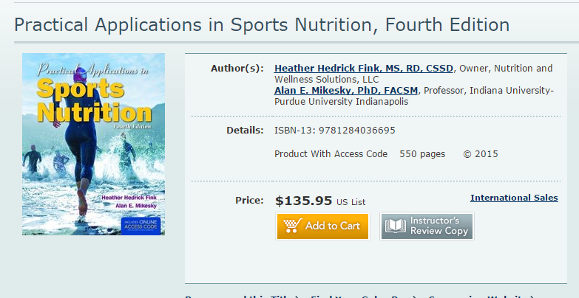
Revised and updated to keep pace with changes in the field, the Fourth Edition of Practical Applications in Sports Nutrition provides students and practitioners with the latest sports nutrition information and dietary practices so they can assist athletes and fitness enthusiasts in achieving their personal performance goals. With data and statistics from the latest nutrition research and guidelines, it demonstrates effective ways to communicate sports nutrition messages to athletes and how to motivate individuals to make permanent behavior change.

Early chapters provide an introduction to sports nutrition and give a thorough explanation of macronutrients, micronutrients, and water and their relation to athletic performance. Later chapters focus on the practical and applied aspects of sports nutrition including behavior change through consultations and weight management. Chapter 15 targets the unique nutrition requirements of special populations such as athletes who are pregnant, vegetarian, or have chronic diseases. The text concludes with a chapter dedicated to helping readers discover the pathway to becoming a sports dietitian through education and experience.
The following instructor resources are available to qualified instructors for download
ISBN-13: 9781284036695

Angel ready Test Bank
BlackBoard ready Test Bank
Desire to Learn ready Test Bank
Image Bank
Instructor Manual
Moodle ready Test Bank
Slides in PowerPoint Format
Test Bank

WEARABLE TECHNOLOGY
Journals and reports:

Apps to promote physical activity among adults: a review and content analysis
https://ijbnpa.biomedcentral.com/articles/10.1186/s12966-014-0097-9

Health Enhancement Research Organization:
http://hero-health.org/wp-content/uploads/2015/06/HERO-Wearables-in-Wellness-Report-FINAL1.pdf

Sensors | Free Full-Text | A Review of Accelerometry-Based Wearable Motion Detectors for Physical Activity Monitoring
http://www.mdpi.com/1424-8220/10/8/7772/html

Evaluation of a text supported weight maintenance programme ‘Lighten Up Plus’ following a weight reduction programme: randomised controlled trial | International Journal of Behavioral Nutrition and Physical Activity | Full Text
http://ijbnpa.biomedcentral.com/articles/10.1186/s12966-016-0346-1

Promoting physical activity among women using wearable technology and online social connectivity: a feasibility study
http://www.tandfonline.com/doi/abs/10.1080/21642850.2015.1118350

Promoting physical activity among women using wearable technology and online social connectivity: a feasibility study
Can Technology Empower Older Adults to Manage Their Health? – ProQuest
http://search.proquest.com/openview/5a8567726846d6daaf389e2dff3a581f/1?pq-origsite=gscholar

IEEE Xplore Abstract - Gamification designs in Wearable Enhanced Learning for healthy ageing
http://ieeexplore.ieee.org/xpl/login.jsp?tp=&arnumber=7359545&url=http%3A%2F%2Fieeexplore.ieee.org%2Fxpls%2Fabs_all.jsp%3Farnumber%3D7359545

Wearable Sensor/Device (Fitbit One) and SMS Text-Messaging Prompts to Increase Physical Activity in Overweight and Obese Adults: A Randomized Controlled Trial
http://online.liebertpub.com/doi/abs/10.1089/tmj.2014.0176

The validity of consumer-level, activity monitors in healthy adults worn in free-living conditions: a cross-sectional study

JMU-Tracking Health Data Is Not Enough: A Qualitative Exploration of the Role of Healthcare Partnerships and mHealth Technology to Promote Physical Activity and to Sustain Behavior Change | Miyamoto | JMIR mHealth and uHealth http://mhealth.jmir.org/2016/1/e5/

The use of wearable technology to measure energy expenditure, physical activity, and sleep patterns in dementia:
https://secure.jbs.elsevierhealth.com/action/getSharedSiteSession?redirect=http%3A%2F%2Fwww.alzheimersanddementia.com%2Farticle%2FS1552-5260%2815%2902315-8%2Fabstract&rc=0&code=jalz-site

Wearable devices and smartphones for activity tracking among people with serious mental illness — ScienceDirect:
http://www.sciencedirect.com/science/article/pii/S1755296615300223

Feasibility of Behavioral Weight Loss Treatment Enhanced with Peer Support and Mobile Health Technology for Individuals with Serious Mental Illness - Online First – Springer
http://link.springer.com/article/10.1007/s11126-015-9395-x

Design and baseline characteristics of participants in the Enhancing Physical Activity and Reducing Obesity through Smartcare and Financial Incentives (EPAROSFI): A pilot randomized controlled trial ☆ — ScienceDirect
http://www.sciencedirect.com/science/article/pii/S1551714415301518

The Wild Wild West: A Framework to Integrate mHealth Software Applications and Wearables to Support Physical Activity Assessment, Counseling and Interventions for Cardiovascular Disease Risk Reduction — ScienceDirect
http://www.sciencedirect.com/science/article/pii/S0033062016300159

IEEE Xplore Abstract - Wearable Sensors for Human Activity Monitoring: A Review:
http://ieeexplore.ieee.org/xpl/login.jsp?tp=&arnumber=6974987&url=http%3A%2F%2Fieeexplore.ieee.org%2Fxpls%2Fabs_all.jsp%3Farnumber%3D6974987

IEEE Xplore Abstract - Communicating and interpreting wearable sensor data with health coaches
http://ieeexplore.ieee.org/xpl/login.jsp?tp=&arnumber=7349402&url=http%3A%2F%2Fieeexplore.ieee.org%2Fxpls%2Fabs_all.jsp%3Farnumber%3D7349402

Wireless sensor network based wearable smart shirt for ubiquitous health and activity monitoring ☆ — ScienceDirect http://www.sciencedirect.com/science/article/pii/S0925400509003724

Healthcare & Digital Apps :http://www.wearabletechnologyshow.net/healthcare-digital-apps

Wearable Technology | Advantages and Disadvantages of Wearable Technology and the Future
YouTube: https://m.youtube.com/watch?v=QoJJ-1VcI7w
Blog: http://blog.neongoldfish.com/social-media/the-advantages-and-disadvantages-of-wearable-tech-3
Blog: http://blog.bestdoctors.com/wearable-technology-good-or-bad-for-our-health/
Newsletter: http://usabilitygeek.com/ways-wearable-technology-can-improve-our-lives/

Fashion tech: 20 wearables that are more chic than geek http://www.wareable.com/fashion/wearable-tech-fashion-style;
Fitness & Big Data: How Wearable Tech Is Changing Exercise Research http://m.livescience.com/45634-accelerometers-exercise-research.html

SAMPLE OF APPLICATIONS
Link to stores for free and paid apps: iTunes; Google Play etc

Link to stores for free and paid apps: Smart phone; ipad; Samsung; Kindle….

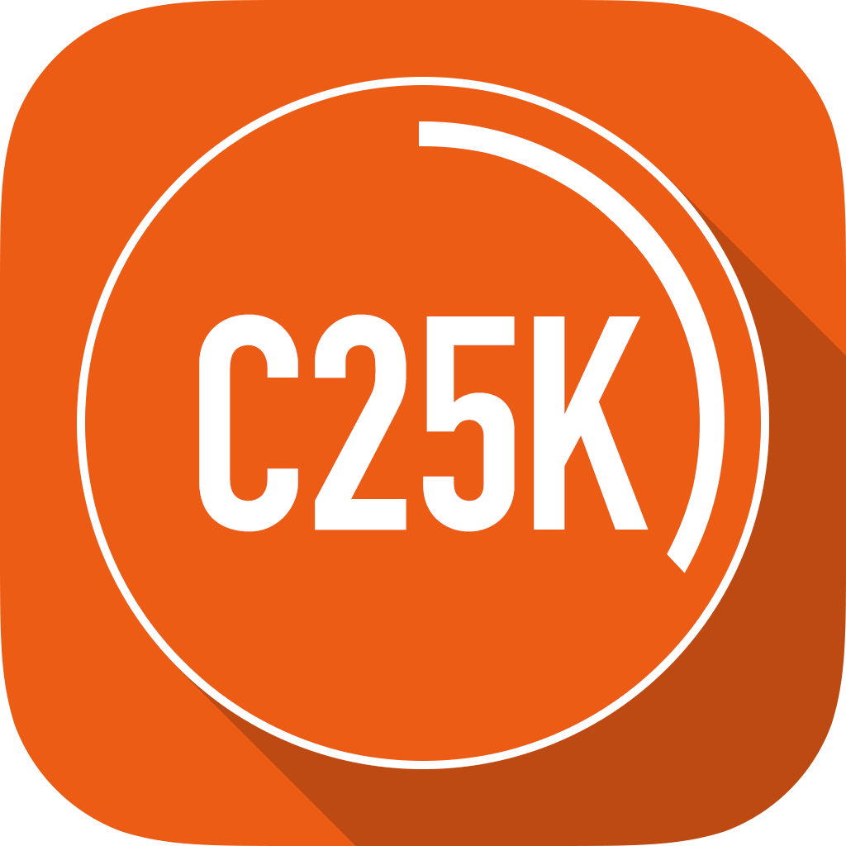
C25K® - 5K Trainer FREE - (Go from Couch Potato to Running the 5K)
By Zen Labs

https://itunes.apple.com/gb/app/c25k-5k-trainer-free-go-from/id485971733?mt=8

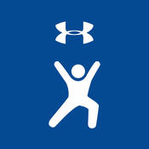
Map My Fitness - GPS Workout Trainer for Fitness, Step and Activity Tracking
By MapMyFitness

https://itunes.apple.com/us/app/map-my-fitness-gps-workout/id298903147?mt=8

Runkeeper - GPS Running, Walk, Cycling, Workout, Pace and Weight Tracker
By FitnessKeeper, Inc.

https://itunes.apple.com/us/app/runkeeper-gps-running-walk/id300235330?mt=8

Fitbit
By Fitbit, Inc.

https://itunes.apple.com/gb/app/fitbit/id462638897?mt=8

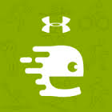

Running and Walking with Endomondo
By endomondo.com
https://itunes.apple.com/gb/app/running-walking-endomondo/id333210180?mt=8

PROGRAMME OF HEALTH ENHANCING PHYSICAL ACTIVITY BASED ON WALKING SPORTS

Scientific journals
(some are open sources)
American Journal of Health Education
American Journal of Preventive Medicine
Annual Review of Nutrition
Applied Physiology, Nutrition and metabolism
Asian Journal of Exercise and Sports Science (AJESS)
Asian Journal of Health and Medical Research (AJHMR)
Australian and New Zealand Journal of Public Health
Australian Journal of Nutrition and Dietetics
Baltic Journal of Health and Physical Activity
BMC public health-MEDLINE®/PubMed®
British Journal of Sports Medicine
European Journal of Public Health
European review of aging and physical activity
International Journal of Behavioral Nutrition and Physical Activity (IJBNPA) https://ijbnpa.biomedcentral.com/
International Journal of Sports Nutrition
Journal of aging and physical activity
Journal of Diabetes Science and Technology
Journal of Electronic Resources in Medical Libraries
Journal of Exercise Science & Fitness
Journal of the International Society of Sports Nutrition
Journal of medical Internet research
Journal of Physical Activity and Health http://journals.humankinetics.com/about-jpah
Mental Health and Physical Activity
Revista internacional de medicina y ciencias de la actividad física y del deporte

Journals for Physical Education and Sport http://www.supportrealteachers.org/journals-for-physical-education-and-sport.html

Books
Armour, K. (2011) Sport Pedagogy: An Introduction for Teaching and Coaching. Abingdon:Taylor and Francis Routledge.
Kidman, L. and Hanrahan, S.J. (2011) The coaching Process: A practical guide to becoming an effective coach. Abingdon: Routledge
Martens, R. (2012) Successful Coaching. Champaign, Illinois: Human Kinet
Metzler, M.W. (2011) Instructional models for Physical Education 3rd ed. Scottsdale, AZ: Holcomb Hathaway
Nash, C (2014) Practical Sports Coaching. Abingdon: Routledge
Sports coach UK and Women’s Sport and Fitness Foundation (2011)
‘Women and Informal Sport: A Report for the Women’s Sport and Fitness Foundation’,
www.sportscoachuk.org/women-informal-sport

Walking sports: web pages

- basketball (http://www.surreysportspark.co.uk/sports/Basketball/Walking%20Basketball/)
- netball (http://www.englandnetball.co.uk/my-game/Walking_Netball)
- rounders (http://www.roundersengland.co.uk/play/rules/)
- football (http://www.walkingfootballunited.co.uk/ ; http://www.worldamputeefootball.com/rules_i.htm)
- hockey https://www.youtube.com/watch?v=HRPYmHzI70s
- rugby (http://www.telegraph.co.uk/news/health/elder/11816791/Rugby-as-youve-never-seen-it-before-older-players-give-game-a-more-genteel-pace.html
- Physical Activity and Adults http://www.who.int/dietphysicalactivity/factsheet_adults/en/

