Tim Long Output 1

Mr Big
To be Cross-Referred to Sub-Panel 34: Art & Design – History, Practice & Theory

Research Narrative:
Field of research
My research experiments with handmade material art objects that seek to animate aspects of the subjectile. I engage in a process to create objects that are intended to possess qualities of my subjective concerns. The objects I make reference anthropological and modernist sources and production methods. Both these sources deploy archaic forms that reference the human body, and through metaphor also demonstrate human forces and potential.
Context
In my work Mr Big the paternal metaphor is elaborated both through the title and the formal presentation of the male form, reminiscent of the Greek Herm. The object examines the vertical, phallic Herm, a symbol for territorial demarcation used in ancient Greece that was later adopted by the Romans. My piece Mr Big was exhibited as part of an exhibition reflecting on the enigmatic, and intriguing, lure of desire. Mr Big, 200cm high, is carved from an oak beam and stands on a tapered plinth. The face is covered with upholstery tacks, almost as if covered with bees. The tacks serve as an ambivalent metaphor for protecting armour, and a suffocating shroud. It examines a specific masculine subject elaborated through the metaphor of the father represented through the form of the phallus. Mr Big examines an iconic manifestation of a particular representation of symbolic male power.
Innovation
Viewers of the work have commented that the work maintains a presence beyond its material mass and seems to be a person, a subject. This interpretation is in part due to the human scale of the work but also may be due to the affective power inherent to the upright vertical Herm-type used a territorial marker and architectural motif. Mr Big is a subjectile: it is neither subject or object because it manifests through its material form aspects of a specific type of male subjectivity that operates in society symbolically, and is identified through archaic and abstract representations of the human body. (Word Count: 424)

Indicators of Quality: Exhibited as part of a multimedia International Exhibition titled Mrs Darling’s Kiss at Arch 402 Gallery, London, July 2011, as the result of invitation and selection from a short-list. The exhibition included work by Joan Ashworth, Steve Bunn, Louise Bourgeois, Tom Chamberlain, Stephen Chambers, Denise de Cordova, Kate Davis, Jonas Grimas, Jane Harris, Tim Long, Rosa Loy, Lee Maelzer, Kate Rowells, Fiona Shaw, and Mike Taylor.

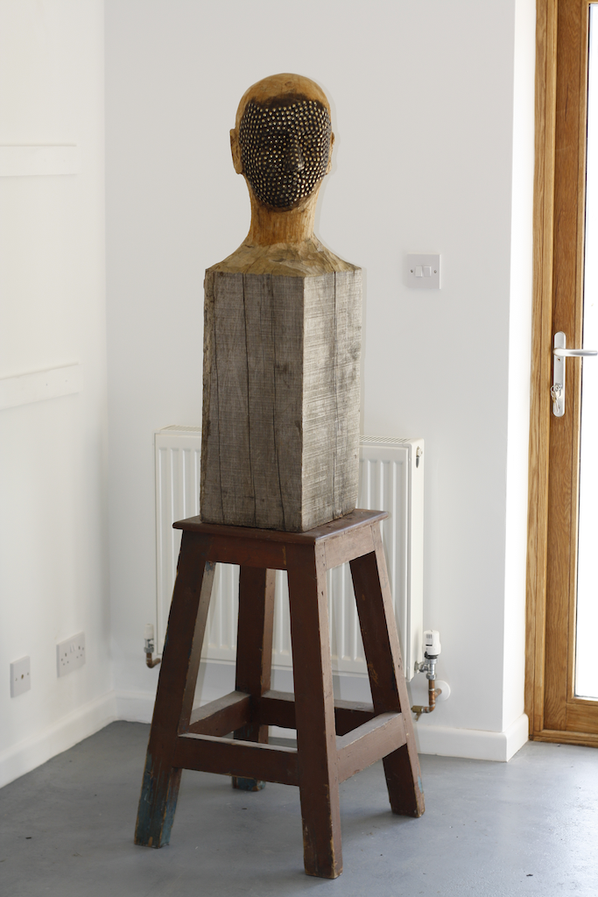
Figure 1 Mr Big
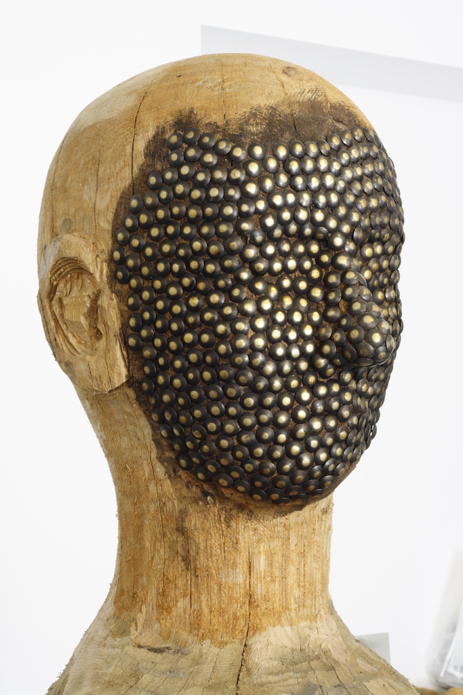
Figure 2 Mr Big, detail

