‘Mrs. Darling’s Kiss’ opens at Arch 402 Gallery in Hoxton
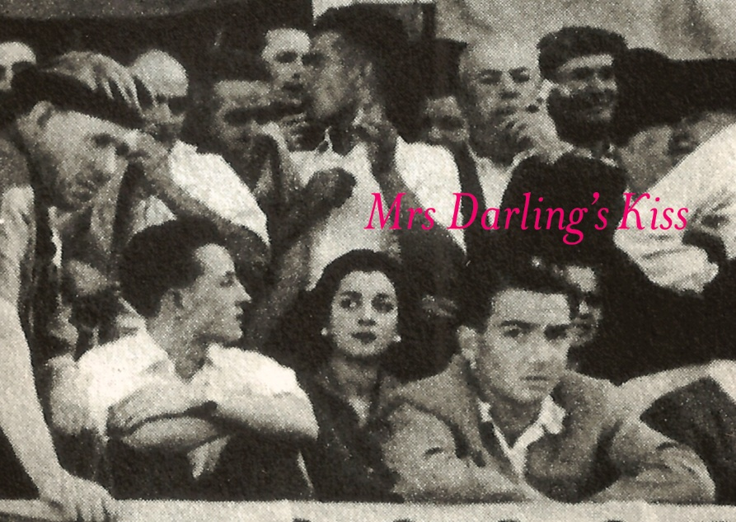
‘Mrs. Darling’s Kiss’ opens at Arch 402 Gallery today (to August 5), showing a mix of sculpture, print and painting by international artists including Kate Davis/David Moore (above), Louise Bourgeois, Tom Chamberlain, Dexter Dymoke and Joan Ashworth (below). Set in a converted railway arch by Hoxton overground station, the gallery has a great outside space; this has been turned into an artist-made outdoor cinema where films that have inspired some of the participating artists (‘Distant Voices, Still Lives’, ‘The Night of the Hunter’) will be screened.
Arch 402 Gallery, Cremer Street, E2 8HD
http://now-here-this.timeout.com/2011/07/08/mrs-darlings-kiss-arch-402-gallery/
Mrs. Darling’s Kiss
A group exhibition incorporating sculpture, print, painting, film and an artist-made outdoor cinema
8 July—5 August 2011
Opening View:
Thursday 7 July 6:00-9:00pm

Works by: Joan Ashworth, Louise Bourgeois, Steve Bunn, Tom Chamberlain, Stephen Chambers, Denise de Cordova, Kate Davis & David Moore, Dexter Dymoke, Jonas Grimas, Jane Harris, Tim Long, Rosa Loy, Lee Maelzer, Nicholas Pankhurst, Kate Rowles, Fiona Shaw and Mike Taylor.
On 7th July, Arch 402 Gallery presents Mrs. Darling’s Kiss, a multimedia group exhibition featuring works by UK-based and international artists who reflect and ‘know’ the enigmatic, the intriguing, the frustrations and lure of desire. The resulting works, ranging from painting to sculpture, installation and film, highlight the hidden power and potency that comes from artifice and its ability to linger in our imagination. The exhibition title takes its cue from the J.M. Barrie writings about Peter Pan, in which Mrs. Darling possesses an unreachable kiss.
The Enigma Of Mrs. Darling’s Kiss….
…Or perhaps not. One of the beauties of fictional characters is that they are constructed beings, a dense compression of experiences, yearnings and emotions. They are observed distillations of possibilities, whose power and potency come from their artifice and their ability to linger in our imagination. In this way, they can become a proposition, a hunch to follow.
We know Mrs. Darling, we recognise the idea of her:
“She was a lovely lady, with a romantic mind and such a sweet mocking mouth. Her romantic mind was like the tiny boxes, one within the other, that come from the puzzling East, however many you might discover there is always one more, and her sweet mocking mouth had one kiss on it that Wendy could never get, though there it was, perfectly conspicuous in the right hand corner.” (1)
For us, the invitation to choose work that we envisaged together has been a great privilege, which we have the artists to thank. It’s been harder to pin down the timbre of the exhibition. Neither of us are theorists. How do you try to describe and attempt to encapsulate a quality that you’re looking for in work (and that paradoxically exists before your eyes) when, by it’s very nature it is elusive?
J.M. Barrie gets straight to the heart of it, nailing a metaphor and construct that knows the lure, intrigue and frustration of the desire and the unreachable. Mr. Darling beat all Mrs. Darling’s many suitors, and…
…“got all of her, except the innermost box and the kiss. He never knew about the box, and in time he gave up trying for the kiss.” (2)
We are with Mr. Darling here, we don’t want to own it. We want to see Mrs. Darling’s slippery, side stepping conceptual kiss. What’s crept upon is the awareness that there is an approach to the work in the context of this exhibition that delights in shimmery shape-shiftery, that has an appetite for the mid sentence, the frustration of the missing page, and the half-heard and misheard. Work that creates space for the imagination to fill in. A concern for surface in its broadest sense is also fundamental—whether made or understood as a kind of veil; surfaces that act as a kind of veneer, or that pose questions beyond the appearance of things. Narrative as a surface for the structure of making—whether film, painting, print or sculpture, the works know weirdness, darkness, joy and beauty to create a staging for Mrs. Darling’s kiss.
⎯Stephen Chambers and Denise de Cordova
This exhibition is curated by Stephen Chambers and Denise de Cordova and is accompanied by a Film Programme and Artist Discussion for the duration of the exhibition.
References
(1) Barrie J.M., Peter Pan, p. 1. Vintage 2009.
(2) Barrie J.M., Peter Pan, p. 2. Vintage 2009.
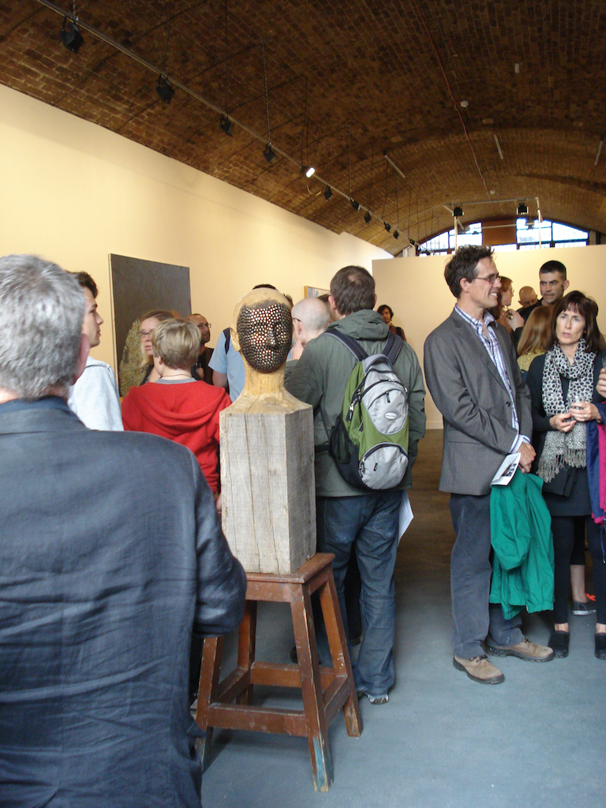
‘Mr Big’, Tim Long 2011

